

**GROUP ASSIGNMENT**

**TECHNOLOGY PARK MALAYSIA**

**CT108-3-1-PYP-LAB-54**

**PYTHON PROGRAMMING**

**APU1F2311CS(AI) & APU1F2311CS(DF)**

**GROUP NUMBER: 12**

|  |  |  |
| --- | --- | --- |
| **LECTURER** | **:** | **MRS. SATHIAPRIYA A/P RAMIAH** |

|  |  |  |  |
| --- | --- | --- | --- |
| **No.** | **Student Name** | **TP Number** | **Roles** |
| 1. | Ng Ming Le | TP079013 | Administrator |
| 2. | Manreen Kaur A/P Jagjit Singh | TP071290 | Trainer |
| 3. | Nurul Aiman Binti Raizal Azhar | TP079309 | Lecturer |
| 4. | Sehba Hanief | TP078886 | Student |

Group Leader: Ng Ming Le

Figure 2. 1 Replace or Delete Line 60 3

Figure 2. 2 Update Profile 62 3

Figure 2. 3 Login 65 3

Figure 2. 4 Display Profile 67 3

Figure 2. 5 User Profile 70 3

Figure 2. 6 Add Class 72 3

Figure 2. 7 Write and View Feedback 74 3

Figure 2. 8 Add Coaching Class Information 77 3

Figure 2. 9 Update Coaching Class Information 82 3

Figure 2. 10 Delete Coaching Class Information 83 3

Figure 2. 11 View Student's Payment Status 86 3

Figure 2. 12 Trainer's Menu 88 3

Figure 2. 13 Call function to log in 90 3

Figure 4. 1 102 4

Figure 4. 2 102 4

Figure 4. 3 103 4

Figure 4. 4 104 4

Figure 4. 5 105 4

Figure 4. 6 106 4

Introduction. 5

Assumptions. 6

Design of the program. 8

Student 1, Pseudocode, Administrator (Ng Ming Le, TP079013) 8

Student2, Pseudocode, Trainer (Manreen Kaur A/P Jagjit Singh, TP071290) 25

Student 3, Pseudocode, Lecturer (Nurul Aiman Binti Raizal Azhar, TP079309) 39

Student 4, Pseudocode, Student (Sehba Hanief, TP078886) 45

Explanation of Programming Concepts. 48

Student 1, Administrator (Ng Ming Le, TP079013) 48

Student2, Trainer (Manreen Kaur A/P Jagjit Singh, TP071290) 60

Student 3, Lecturer (Nurul Aiman Binti Raizal Azhar, TP079309) 92

Student 4, Student (Sehba Hanief, TP078886) 101

Additional features source code with explanation (if have). 106

Student 1, Administrator (Ng Ming Le, TP079013) 106

Student 2, Trainer (Manreen Kaur A/P Jagjit Singh, TP071290) 106

Student 3, Lecturer (Nurul Aiman Binti Raizal Azhar, TP079309) 106

Student 4, Student (Sehba Hanief, TP078886) 106

Screenshots of sample input/output (for the whole system). 107

Conclusion. 133

References. 134

Work Breakdown Structure 136

Figure 2. 1 Replace or Delete Line 60

Figure 2. 2 Update Profile 62

Figure 2. 3 Login 65

Figure 2. 4 Display Profile 67

Figure 2. 5 User Profile 70

Figure 2. 6 Add Class 72

Figure 2. 7 Write and View Feedback 74

Figure 2. 8 Add Coaching Class Information 77

Figure 2. 9 Update Coaching Class Information 82

Figure 2. 10 Delete Coaching Class Information 83

Figure 2. 11 View Student's Payment Status 86

Figure 2. 12 Trainer's Menu 88

Figure 2. 13 Call function to log in 90

Figure 4. 1 102

Figure 4. 2 102

Figure 4. 3 103

Figure 4. 4 104

Figure 4. 5 105

Figure 4. 6 106

# Introduction.

Python programming language is a high degree due to its clarity and readability coding that displays a straightforward syntax. Python is created by Guido van Rossum assisting diverse programming paradigms for scripting, web development and other motives. Furthermore, Python is versatile, wide-ranging, and active support. This innovative system is a pivotal platform targeted at optimizing and constructing the APU Programming Café of an online management system by utilizing Python to code, facilitating the administration of coaching class information modules, commensurate current competency skills, fostering a conducive environment, and assisting students who seek guidance.

The core ethos of this system revolves inclusively and adapts to acknowledge the necessity and inspire to embark student’s journey. This structure caters to students of academic progression by offering a robust framework of classes from Foundation to Degree Level 3 based on the levels (Beginner, Intermediate, and Advanced). There are three modules for the coaching classes which are Introduction to Networking, Operating System to Computer Architecture, and Programming with Python. The coaching process streamlines the system that accommodates four classifications of registered users which are Administrator, Trainer, Lecturer, and Student roles. Each of these roles has functionalities to make certain that the cooperation within the system is well-maintained. The Python platform integrates characteristics like user authentication, role identification, and its requirements to perform the objectives to satisfy the criteria of user division.

The coaching class timetable and information are updated regularly for data accuracy. The financial transactions and payments are handled safely with appropriate mechanisms. The student’s information is stored accurately and maintained by the lecturers confidentially. The system is managed under secured network infrastructure to avoid confidential data spreading. This platform is online and requires stable access to the Internet for consistent interaction.

## Assumptions.

There are a variety of assumptions made in this system such as user authentication, user roles, and data gathered and organized in the system. Primarily, the system assumes the end users adhere the ethical practices to utilize the system based on their appointed roles accountably.

* **User Authentication:**
* Log in using username, email address, and password accurately that are unique and secured control.
* This system allows a maximum of three login attempts.
* **User Roles:**
* After logging in successfully, the system analyses the user’s role and directs them to the corresponding menu options based on role.
* **Administrator:**
* This role has the authority to register and delete trainers.
* This role has the authority to assign trainers to certain levels and modules. The trainer can teach more than one module.
* This role has the authority to view monthly income reports based on trainer, level, and modules.
* This role has the authority to view feedback from trainers.
* This role has the authority to update own profile.
* **Trainer:**
* This role can command to add coaching class information (Level, Subject, Day, Date, Venue, Charges, if it is Additional Coaching Class).
* This role can command to view list of students paid and enrolled in their modules.
* This role can command to send feedback to the administrator.
* This role can command to update own profile.
* **Lecturer:**
* This role can control the registration and enrolment of students in modules requiring coaching.
* This role can control to update student’s enrolment information(s).
* This role can control to approve requests from students to enrol in additional coaching class(es).
* This role can control to deletion of the student’s record that has completed coaching class(es).
* This role can control to update own profile.
* **Student:**
* This role has the rights to view own coaching class schedules.
* This role has the rights to send requests to lecturers for enrolment in additional coaching classes for different modules.
* This role has the rights to delete pending requests sent to lecturer to enrol additional coaching class.
* This role has the rights to view invoice and make payments for enrolled modules.
* This role has the rights to update own profile.

# Design of the program.

## Student 1, Pseudocode, Administrator (Ng Ming Le, TP079013)

Start

FUNCTION ReplaceOrDeleteLine(Filename, LineNumber, RorD, ListContent = "None"):

IF RorD is"R" then

Str = ListContent

Replace Lines[LineNumber - 1] with Str

Lines = REMOVE_EMPTY_LINES(Lines)

write all lines to file(Filename, Lines)

Else IF RorD is "D" then

Lines = read all line from file(Filename)

remove Lines[LineNumber - 1] from file

write all lines to file(Filename, Lines)

ENDIF

END FUNCTION

FUNCTION UpdateProfile(UserList):

Option = Prompt user to select the function

CASE OF Option:

= "1":

Gmail = Prompt user for new gmail

UserList[3] = Gmail

= "2":

ContactNumber = Prompt user for new contact number

UserList[4] = ContactNumber

= "3":

Address = Prompt user for new address

UserList[5] = Address

OTHERWISE

Display "Unknown Option"

ENDCASE

IF UserList[2] is "Administrator" OR UserList[2] is "Trainer" OR UserList[2] is "Lecturer" then

WITH OPEN("namelist - profile.txt", "r") AS file DO

LineNumber = 0

DOWHILE EACH line IN file DO

IF UserList[0] is line[0] then

ReplaceOrDeleteLine("namelist - profile.txt", LineNumber, "R", UserList)

Display "Update Successfully"

Break

ENDIF

LineNumber += 1

ENDDO

ENDFILE

Else IF UserList[2] != "Administrator" OR UserList[2] != "Trainer" OR UserList[2] != "Lecturer" then

WITH OPEN("student.txt", "r") AS file DO

LineNumber = 0

DOWHILE EACH line IN file DO

IF UserList[0] is line[0] then

Display UserList

Students = CALL Read_Student()

Students[LineNumber] = UserList

CALL Write_Student (Students)

Display "Update Successfully"

UserList[2] = "Student"

Break

ENDIF

LineNumber += 1

ENDDO

ENDFILE

ENDIF

RETURN UserList

END FUNCTION

FUNCTION Login():

UserList = []

Username = None

Password = None

detect = False

DOWHILE NOT detect DO

Username = Prompt user for username

WITH OPEN("namelist - profile.txt", "r") AS file DO

DOWHILE EACH line IN file DO

IF Username is line[0] OR Username is line[3] then

Password = line[1]

detect = True

Break

ENDIF

ENDDO

ENDFILE

IF NOT detect then

WITH OPEN("student.txt", "r") AS file DO

DOWHILE EACH line IN file DO

IF Username is line[0] OR Username is line[3] then

Password = line[1]

UserList[2] = "Student"

detect = True

Break

ENDIF

ENDDO

ENDFILE

ENDIF

IF NOT detect then

Display "User not found"

ENDIF

ENDDOWHILE

DOWHILE a FROM 0 TO 2 DO

password = Prompt user for password

IF password is Password then

Display "Log in successfully"

RETURN UserList

ELSE

Display "Wrong Password! Pls try again"

ENDIF

ENDDO

END FUNCTION

FUNCTION DisplayProfile(UserList):

Display "-------------------------Profile-------------------------"

Display "{:^70}".Format(" ")

Display Name, Role ,Gmail ,Contact Number ,Address

IF Level and Module exist then

Display Level and Module

ENDIF

END FUNCTION

FUNCTION UserProfile(UserList):

DisplayProfile(UserList)

Display "-------------------------Menu-------------------------"

CASE OF UserList[2]:

= "Administrator":

RETURN "Admin"

= "Trainer":

RETURN "Trainer"

= "Lecturer":

RETURN "Lecturer"

= "Student":

RETURN "Student"

END FUNCTION

FUNCTION AssignModule():

module = []

Display "Module:"

WITH OPEN("CoachingclassinFormation.txt", "r") AS file DO

DOWHILE EACH line IN file DO

str = password

APPEND module, str

ENDDO

ENDFILE

List = []

DOWHILE b IN module DO

APPEND List, b[0]

DOWHILE a FROM 1 TO LENGTH(List) DO

Display List

ENDDO

Module = ""

DOWHILE True DO

Option = Prompt user for the module

IF Option is digit( then

LevelList = []

IF Option <= LENGTH(module) then

DOWHILE b IN module DO

IF (List[Option - 1] is b[0]) then

APPEND LevelList, b

ENDIF

ENDDO

ENDIF

DOWHILE a FROM 1 TO LENGTH(LevelList) DO

Display f"{a}.{LevelList[a - 1]}"

ENDDO

DOWHILE True DO

Option1 = Prompt user for the module

IF Option1.isdigit() then

IF Option1 > 0 AND Option1 < LENGTH(LevelList) + 1 then

Module += LevelList(Option)

ELSE

Display "Unknown Option"

ENDIF

ENDIF

ENDDOWHILE

ELSE

Break

ENDIF

ENDDOWHILE

RETURN Module

END FUNCTION

FUNCTION Register(Role):

DOWHILE True DO

Name = Prompt user for new lecturer name

WITH OPEN("namelist - profile.txt", "r") AS file DO

DOWHILE EACH a IN file DO

IF Name already in file then

Display "This name already used!"

ENDIF

ENDDO

ENDFILE

Break

ENDDOWHILE

Password = Prompt user for new lecturer password

Gmail = Prompt user for new lecturer gmail

Address = Prompt user for new lecturer address

ContactNumber = Prompt user for new lecturer contact number

Level = Prompt user for new lecturer level

CASE OF Level:

= "1":

Level = "Beginner"

= "2":

Level = "Intermediate"

= "3":

Level = "Advance"

OTHERWISE

Display "Unknown Option"

RETURN  
 ENDCASE

Module = AssignModule()

WITH OPEN("namelist - profile.txt", "a") AS file DO

write updated profile to file

ENDWITH

Display "Register Successfully"

END FUNCTION

FUNCTION ViewList(Role):

WITH OPEN("namelist - profile.txt", "r") AS file DO

DOWHILE EACH User IN file DO

IF role in file is Trainer then

Display Trainer details

ENDIF

ENDDO

ENDFILE

RETURN NameList

END FUNCTION

FUNCTION AssignLevelAndMoodle(Role):

TrainerList = CALL ViewList(Role)

number = prompt user for the lecturer which needs to be removed

founded = False

line = None

LineNum = None

DOWHILE EACH User IN TrainerList DO

IF number is the number of the trainer then

DeletedUser = trainer username

founded = True

WITH OPEN("namelist - profile.txt", "r") AS file DO

DOWHILE EACH a, line IN ENUMERATE(file, 1) DO

IF name in file is DeletedUser AND role in file is Role

then

Break

ENDIF

ENDDO

ENDFILE

DisplayProfile(line)

ENDIF

ENDDO

IF NOT founded then

Display "Unknown FUNCTION"

ELSE

Check = Prompt user for the decision to change or not

IF Check is true then

Display "Re-Assign Cancelled"

RETURN

ENDIF

Level = Prompt user for the level

CASE OF Level:

= "1":

Level = "Beginner"

= "2":

Level = "Intermediate"

= "3":

Level = "Advance"

OTHERWISE

Display "Unknown Option"

RETURN

ENDCASE

Module = CALL AssignModule()

CALL ReplaceOrDeleteLine("namelist - profile.txt", LineNum, "R", line)

Display "Re-Assign Successfully"

ENDIF

END FUNCTION

FUNCTION Delete(Role):

TrainerList = ViewList(Role)

IF Prompt user for the decision to delete or not then

number = Prompt user for the details which need to be removed

founded = False

DOWHILE EACH User IN TrainerList DO

IF number is User[0] then

DeletedUser = User[1]

founded = True

WITH OPEN("namelist - profile.txt", "r") AS file DO

DOWHILE EACH a, line IN ENUMERATE(file, 1) DO

IF username in file is DeletedUser AND role in file is Role then

DisplayProfile(line)

IF Prompt user for the decision to delete this user is True then

Display "Deleted Successfully"

ReplaceOrDeleteLine("namelist - profile.txt", a, "D")

RETURN

ELSE

Display "Deleted Cancelled"

RETURN

ENDIF

ENDIF

ENDDO

ENDFILE

ENDIF

ENDDO

ELSE

RETURN

ENDIF

IF NOT founded then

Display "Unknown Option"

ENDIF

END FUNCTION

FUNCTION Feedback():

WITH OPEN("Feedback.txt", "r") AS file DO

DOWHILE EACH Line IN file DO

Display Name, Content

ENDDO

ENDFILE

END FUNCTION

FUNCTION CountStudentAmount():

Create an empty dictionary Dict

WITH OPEN("student.txt", "r") AS file DO

DOWHILE EACH line IN file DO

Module = module in file

DOWHILE EACH Module IN module DO

IF Module in Dict then

Dict[Module] += 1

ELSE

Dict[Module] = 1

ENDIF

ENDDO

ENDDO

ENDFILE

RETURN Dict

END FUNCTION

FUNCTION ViewMonthlyIncomes():

StudentDetail = CountStudentAmount()

Get the module level, module name and module’s cost

Select = Prompt user for the decision for the type of Monthly Incomes Report,1.Trainer2.Level3.Module

CASE OF Select:

= "1":

TrainerList = ViewList("Trainer")

Number = Prompt user for the trainer

founded = False

DOWHILE EACH Trainer IN TrainerList DO

IF Number is number of Trainer then

founded = True

Fee = []

WITH OPEN("CoachingclassinFormation.txt", "r") AS file DO

DOWHILE EACH line IN file DO

IF line[3] is Trainer[1] then

count = Level of module,name of module and module’s cost

APPEND Fee, count

ENDIF

ENDDO

ENDFILE

DOWHILE content IN Fee DO

DOWHILE EACH line IN List DO

IF line[0] is content[0] AND line[1] is content[1] then

StudentNumber = line[2]

Break

ENDIF

ENDDO

amount = StudentNumber * content[2]

total += amount

Display number, content[0], content[1], StudentNumber, content[2], amount)(Trainer monthly income report)

ENDDO

Display total

ENDIF

ENDDO

IF NOT founded then

Display "Unknown Command!"

RETURN

ENDIF

= "2":

option = Prompt user for the level(1.Advance\n2.Intermediate\n

3.Beginner)

CASE OF option:

= "1":

Lvl = "Advance"

= "2":

Lvl = "Intermediate"

= "3":

Lvl = "Beginner"

OTHERWISE

Display "Unknown Option"

RETURN  
 ENDCASE

END=

Fee = []

WITH OPEN("CoachingclassinFormation.txt", "r") AS file DO

DOWHILE EACH line IN file DO

IF line[0] is Level then

count = [line[1], line[0], line[8]]

APPEND Level, module name , module’s cost to Fee

ENDIF

ENDDO

ENDFILE

DOWHILE content IN Fee DO

DOWHILE EACH line IN List DO

IF level of module and module name are same in both list then

Break

ENDIF

ENDDO

amount = number of student * fee of the module

total += amount

Display number, content[0], content[1], StudentNumber, content[2], amount)(level monthly income report)

ENDDO

Display total

= "3":

module = []

Display "Module:"

WITH OPEN("CoachingclassinFormation.txt", "r") AS file DO

DOWHILE EACH line IN file DO

str = line[1], line[0]

APPEND module, str

ENDDO

ENDFILE

Module = []

DOWHILE EACH b IN module DO

APPEND Module, b[0]

ENDDO

DOWHILE line IN Module DO

Display Module

ENDDO

moduleNum =Prompt user to select module

Fee = []

WITH OPEN("CoachingclassinFormation.txt", "r") AS file DO

DOWHILE EACH line IN file DO

IF line[1] is Module[moduleNum - 1] then

count = [line[1], line[0], line[8]] # add student number

APPEND Fee, count

ENDIF

ENDDO

ENDFILE

DOWHILE content IN Fee

DOWHILE EACH line IN List

IF level of module and module name are same in both list then

Break

ENDIF

ENDDO

amount = number of student * fee of the module

total += amount

Display number, content[0], content[1], StudentNumber, content[2], amount)( module monthly income report)

ENDDO

Display total

OTHERWISE

Display "Unknown Option"

RETURN

ENDCASE

END=

END FUNCTION

FUNCTION Admin():

option = Prompt user to select the function(1.Update Profile\n2. Register New Trainer,3.View/Delete Trainer4.View feedback ,5.Re-Assign Trainer,6.View Monthly Incomes,9.Log Out)

CASE OF option:

= "1":

CALL UpdateProfile(UserList)

= "2":

CALL Register(“Trainer”)

= "3":

CALL Delete("Trainer")

= "4":

CALL Feedback()

= "5":

CALL ViewMonthlyIncomes()

= "9":

Display "Log Out Successfully!\n"

Display 10 empty line

Return “q”

Otherwise:

Display(“Unknown Option”)

ENDCASE

END FUNCTION

DOWHILE(TRUE)

UserList = CALL Login()

DOWHILE(TRUE)

status = CALL UserProfile(UserList)

IF status is “Admin”:

IF CALL Admin() is “q”:

Break

ENDIF

ENDIF

IF status is “Lecturer”:

IF CALL Lecturer() is “q”:

Break

ENDIF

ENDIF

IF status is “Trainer”:

IF CALL Trainer() is “q”:

Break

ENDIF

ENDIF

IF status is “Student”:

IF CALL Student() is “q”:

Break

ENDIF

ENDIF

ENDDO

ENDDO

END

## Student2, Pseudocode, Trainer (Manreen Kaur A/P Jagjit Singh, TP071290)

Start

Function ReplaceOrDeleteLine(Filename, LineNumber, RorD, ListContent = "None")

IF RorD equals "R" THEN

Read file lines from Filename

Join ListContent into a string Str

Strip each line in Lines

Write Lines back to Filename

ELSE IF RorD equals "D" THEN

Read file lines from Filename

Delete line at LineNumber - 1 from Lines

Write Lines back to Filename

ENDIF

End Function

Function UpdateProfile(UserList)

IF UserList[2] is not "Administrator" OR "Trainer" OR "Lecturer" THEN

Remove element at index 2 from UserList

ENDIF

Read Option from user input "1.Gmail\n2.Contact Number\n3.Address\n"

SWITCH Option DO

CASE "1":

Read new Gmail from user input

Assign new Gmail to UserList[3]

CASE "2":

Read new Contact Number from user input

Assign new Contact Number to UserList[4]

CASE "3":

Read new Address from user input

Assign new Address to UserList[5]

DEFAULT:

Print "Unknown Option"

ENDSWITCH

IF UserList[2] is "Administrator" OR "Trainer" OR "Lecturer" THEN

Open "namelist - profile.txt" in read mode as file

Initialize LineNumber as 0

Loop over each line a in file

Split a by comma into a list

IF UserList[0] is equal to a[0] THEN

Call ReplaceOrDeleteLine("namelist - profile.txt", LineNumber, "R", UserList)

Print "Update Successfully"

Exit loop

ENDIF

Increment LineNumber by 1

END Loop

ENDIF

IF UserList[2] is not "Administrator" OR "Trainer" OR "Lecturer" THEN

Open "student.txt" in read mode as file

Initialize LineNumber as 0

Loop over each line a in file

Split a by pipe into a list

IF UserList[0] is equal to a[0] THEN

Call read_students()

Update Students[LineNumber] with UserList

Call write_students(Students)

Print "Update Successfully"

Insert "Student" at index 2 in UserList

Exit loop

ENDIF

Increment LineNumber by 1

END Loop

ENDIF

Return UserList

End Function

Function Login ()

Initialize UserList as empty list

Initialize Username as None

Initialize Password as None

Initialize detect as False

WHILE detect is False DO

Read Username from user input "Username:"

Open "namelist - profile.txt" in read mode as file

Loop over each line a in file

Strip a

Split a by comma into a list

IF Username is equal to a [0] OR Username is equal to a [3] THEN

Assign a [1] to Password

Set detects to True

Exit loop

ENDIF

END Loop

IF detect is False THEN

Open "student.txt" in read mode as file

Loop over each line a in file

Strip a

Split a by pipe into a list

IF Username is equal to a[0] OR Username is equal to a[3] THEN

Assign a[1] to Password

Insert "Student" at index 2 in UserList

Set detect to True

Exit loop

ENDIF

END Loop

ENDIF

IF detect is False THEN

Print "User not found!"

ENDIF

END While

FOR a in range (3)

Read password from user input "Password:"

IF password is equal to Password, THEN

Print "Log in successfully"

Return UserList

ELSE

Print "Wrong Password! Please try again"

ENDIF

ENDFOR

End Function

Function DisplayProfile(UserList)

Print formatted profile information

IF UserList[2] is "Student" THEN

Print formatted student profile information

ELSE

Print formatted non-student profile information

ENDIF

IF length of UserList is greater than or equal to 7 THEN

IF UserList[2] is not "Student" THEN

Print formatted "Level:" information

ENDIF

Print "Moodle:"

Split UserList[7] by plus sign into Moodle

Loop over each moodle in Moodle with index a

Split moodle by period into MoodleInfo

Print formatted Moodle information

END Loop

ENDIF

End Function

Function UserProfile(UserList)

Call DisplayProfile(UserList)

Print formatted menu

SWITCH UserList[2] DO

CASE "Administrator":

Return "Admin"

CASE "Trainer":

Return "Trainer"

CASE "Lecturer":

Return "Lecturer"

CASE "Student":

Return "Student"

ENDSWITCH

End Function

Function AddClass()

Read file_path as "Coachingclassinformation.txt"

Open file_path in read mode as file

Read lines from file and remove trailing whitespace

Print each line in lines

End Function

Function write_feedback()

Assign UserList[0] to name

Read feedback from user input "Enter your feedback:"

Open "Feedback.txt" in append mode as File

Write feedback and UserList[0] to File

Print "Successfully submitted your feedback!"

End Function

Function view_feedbacks()

TRY

Open "Feedback.txt" in read mode as file

Read feedbacks from file

Print "Feedbacks:"

Initialize NO as 0

Loop over each feedback in feedbacks

Split feedback by comma into FeedbackInfo

IF UserList[0] is equal to FeedbackInfo[0] THEN

Increment NO by 1

Print NO and FeedbackInfo[1]

ENDIF

END Loop

EXCEPT FileNotFoundError

Print "Unavailable feedbacks."

ENDTRY

End Function

Function add_coaching_class_information()

Try

Print "Add coaching class information."

Read level_name from user input "Enter level name:"

Read module_name from user input "Enter module name:"

Read class_code from user input "Enter class code:"

Read class_day from user input "Enter class day:"

Read time from user input "Enter the time(00:00,23:59):"

Read venue from user input "Enter the venue:"

Read charges as integer from user input "Enter the charges:"

Read additional_coaching_class from user input "Enter if it is the additional coaching class: (y/n)"

Concatenate level_name, module_name, class_code, UserList[0], class_day, time, venue, charges into new_information

If additional_coaching_class.lower() equals "y" Then

Append ",Additional coaching class" to new_information

Append newline character to new_information

Open "Coachingclassinformation.txt" in append mode as file

Write new_information to file

Open "namelist - profile.txt" in read mode as file

For each line, number in file with index starting from 1 Do

Split line by comma into line

If line[0] equals UserList[0] Then

Extract module from line

Append "+module_name" to module

If additional_coaching_class.lower() equals "y" Then

Append "(Additional)" to module

Append ".level_name" to module

Assign module to line[7]

Remove newline character from line[-1]

Call ReplaceOrDeleteLine("namelist - profile.txt", number - 1, "R", line)

Print "Coaching class information added successfully."

Except ValueError as ve

Print "Error:", ve, ". Please enter a valid numeric value for time and charges."

End Function

Function update_coaching_class_information()

Try

Open "Coachingclassinformation.txt" in read mode as file

Read lines from file

Print "Existing coaching class information:"

Initialize lineNumber as empty list

For each line, index in lines with index starting from 1 Do

Split line by comma into module

If module[3] equals UserList[0] Then

Append index to lineNumber

Print index, ".", line without leading and trailing whitespace

Read line_number from user input "Enter the line number to update:"

If line_number exists in lineNumber Then

Read updated_level_name from user input "Enter the updated level name:"

Read updated_module_name from user input "Enter the updated module name:"

Read updated_class_code from user input "Enter class code:"

Read updated_class_day from user input "Enter the updated class day:"

Read updated_time from user input "Enter the updated time(00:00,23:59):"

Read updated_venue from user input "Enter the updated venue:"

Read updated_charges as integer from user input "Enter the updated charges:"

Read additional_coaching_class from user input "Enter if it is the additional coaching class: (y/n)"

Update lines[line_number - 1] with updated information

If additional_coaching_class.lower() equals "y" Then

Append ",Additional coaching class" to lines[line_number - 1]

Append newline character to lines[line_number - 1]

Open "Coachingclassinformation.txt" in write mode as file

Write lines to file

Print "Coaching class information updated successfully!"

Else

Print "Invalid line number!"

Except ValueError

Print "Invalid input! Please enter a number."

End Function

Function delete_coaching_class_information()

Try

Open "Coachingclassinformation.txt" in read mode as file

Read lines from file

Print "Existing Coaching Class Information:"

Initialize lineNumber as empty list

For each line, index in lines with index starting from 1 Do

Split line by comma into module

If module[3] equals UserList[0] Then

Append index to lineNumber

Print index, ".", line without leading and trailing whitespace

Read line_number from user input "Enter the line number to delete:"

If line_number exists in lineNumber Then

Remove lines[line_number - 1]

Open "Coachingclassinformation.txt" in write mode as file

Write remaining lines to file

Print "Coaching class information deleted successfully!"

Else

Print "Invalid line number."

Except ValueError

Print "Invalid input. Please enter a number."

End Function

Function ViewStudentPaymentStatus()

Read file_path as "Coachingclassinformation.txt"

Open file_path in read mode as file

Read lines from file

For each line in lines Do

Print line without leading and trailing whitespace

While True Do

Print newline

Print "1. View list students enrolled and paid for his/her modules."

Print "2. Exit."

Read option from user input "Enter your option (1 or 2):"

If option equals "1" Then

Call write_feedback()

Else If option equals "2" Then

Print "Exiting the program..."

Exit loop

Else

Print "Invalid choice! Please enter 1 or 2."

End Function

Function Trainer()

Read option from user input "1.Write feedback.\n2.view feedback.\n3.Add coaching class information.\n4.Update coaching class information.\n5.Delete coaching class information.\n6.Update Profile."

Match option

Case "1":

Call write_feedback()

Case "2":

Call view_feedbacks()

Case "3":

Call add_coaching_class_information()

Case "4":

Call update_coaching_class_information()

Case "5":

Call delete_coaching_class_information()

Case "6":

Call UpdateProfile(UserList)

End Function

While True Do

Assign UserList to result of Login ()

While True Do

Assign status to result of UserProfile(UserList)

If status equals "Admin" Then

If result of Admin () equals "q" Then

Exit inner loop

Else If status equals "Lecturer" Then

If result of Lecturer () equals "q" Then

Exit inner loop

Else If status equals "Trainer" Then

If result of Trainer () equals "q" Then

Exit inner loop

Else If status equals "Student" Then

If result of Student () equals "q" Then

Exit inner loop

End While

End

Student 3, Pseudocode, Lecturer (Nurul Aiman Binti Raizal Azhar, TP079309)

Start

Function main ()

Initialize students list

WHILE true

Display menu options

Get user choice

IF choice is 1 THEN

call enroll_student function with students list as parameter

ELSE IF choice is 2 THEN

call update_student function with students list as parameter

ELSE IF choice is 3 THEN

call handle_additional_request function with students list as parameter

ELSE IF choice is 4 THEN

call delete_student function with students list as parameter

ELSE IF choice is 5 THEN

call update_profile function with UserList list as parameter

ELSE IF choice is 6 THEN

Display exit message

break loop

ELSE

Display invalid choice message

Call main()

END FUNCTION

Function enroll_student(students)

Get user input for student details: name, password, TP number, email, contact number, address, enrollment month

Call AssignModule() to assign modules to the student

Create a new_student list with the input data and modules

Append new_student to students

Call write_students(students) to update the file

Print "Student registered successfully

END FUNCTION

Function AssignModule()

Create an empty module list

Open file "Coachingclassinformation.txt" for reading as file

For each line in file:

Split the line by ','

Create a string str with module name

Check if the line has additional classes

Append the formatted str to module

Sort and get unique elements in module list

Create a new List with only module names

Sort and get unique elements in List

Display the module options with numbers

Repeat until user input is 'E':

Get user input for module number

IF the input is a digit within the range of modules:

Get the corresponding levels for the selected module

Display level options

Repeat until user input is valid:

Get user input for level number

IF the input is within the range of levels:

Append the selected module and level to Module

Break the loop

ELSE:

Display "Unknown Option"

ELSE:

Break the loop

Return the selected modules as a string

END FUNCTION

Function update_student(students)

Get the TP number of the student to update from user

Initialize found as False

For each student in the students list

IF the student's TP number matches the user's input

Display the student's current module information

Get the User's choice of module to delete

Update module list

Update student's module with AssignModule() and new modules

Print "Student information updated with the new module"

Set found as True

Break the loop

IF student not found, print "Student not found"

Call write_students(students) to update the file

Function get_lecturer_decision()

get the lecturer's decision from user

IF the decision is 'y'

return true

Else if decision is 'n'

return false

Else

Diplay "Invalid input" and recursively call get_lecturer_decision()

END FUNCTION

Function handle_additional_request(students):

Read additional requests from file

Display pending requests with numbers

Get user input for request number

IF request number is valid:

Get student's TP number, new module and level from the request

For each student in students:

IF student's TP number matches the request:

Display student info and current modules

If lecturer approves request:

Update student's modules with new module and level

Update request status to "Approved"

Print "Student information updated with the new module"

ELSE:

Print "The request is rejected"

Update request status to "Rejected"

Set found as True

Break the loop

IF student not found, print "Student not found"

Call write_students(students) to update the file

END FUNCTION

Function delete_student(students):

Get input for the TP number of student to delete

Initialize found as False

For each student in students:

IF student's TP number matches input TP number:

Delete the student from students

Print "Student deleted successfully"

Set found as True

Break the loop

IF student not found, print "Student not found"

Call write_students(students) to update the file

END FUNCTION

Function ReplaceOrDeleteLine(Filename, LineNumber, RorD, ListContent="None"):

IF RorD is "R":

Read all lines from file and store in Lines

Create a string Str with ListContent joined by ','

Replace

Update Lines at LineNumber with Str

Remove empty lines from Lines

Write Lines back to the file

IF RorD is "D":

Read all lines from file

Delete the line at LineNumber

Write the updated lines back to the file

END FUNCTION

Function update_profile(UserList):

Display UserList

Get user input for profile update option

Match the option:

CASE "1":

Get new Gmail input

Update UserList with the new Gmail

CASE "2":

Get new Contact Number input

Update UserList with the new Contact Number

CASE "3":

Get new Address input

Update UserList with the new Address

DEFAULT:

Print "Unknown Option"

Open file "namelist-profile.txt" for reading as file

Initialize LineNumber as 0

For each line in file:

Split the line by ','

If UserList's name matches the first element of the line:

Replace the line with updated UserList data

Print "Update Successfully"

Break the loop

Increment LineNumber

Return UserList

END FUNCTION

Function read_student():

students = empty list

Open file 'student.txt' for reading as file

For each line in file:

Split the line by '|' and store in student_data

Append student_data to students

Close the file

Return students

END FUNCTION

Function write_students(students):

Open file 'student.txt' for writing as file

For each student in students:

Join student data with '|' and newline character

Write the student_str to file

Close the file

END FUNCTION

END

## Student 4, Pseudocode, Student (Sehba Hanief, TP078886)

*display_menu()*

*function display_menu() {*

*print menu options*

*}*

*while True {*

*get user choice*

*if choice is "1" {*

*view_schedule()*

*}*

*else if choice is "2" {*

*send_request()*

*}*

*else if choice is "3" {*

*delete_request()*

*}*

*else if choice is "4" {*

*create_invoice()*

*}*

*else if choice is "5" {*

*make_payment()*

*}*

*else if choice is "6" {*

*update_profile()*

*}*

*else if choice is "0" {*

*print "Exiting..."*

*break*

*}*

*else {*

*print "Invalid choice. Please enter a number from the menu."*

*}*

*}*

*function view_schedule() {*

*prompt user for day and level*

*read Coachingclassinformation.txt*

*for each line in the file {*

*split line into fields*

*if fields[4] is the entered day and fields[0] is the entered level {*

*print all fields*

*}*

*}*

*}*

*function send_request() {*

*prompt user for TP Number, Module, and Level*

*write to RequestAdditionalCoachingClass.txt*

*print success message*

*}*

*function delete_request() {*

*print existing requests*

*prompt user for TP Number, Module, and Level*

*read RequestAdditionalCoachingClass.txt*

*write lines that don't match the input to RequestAdditionalCoachingClass.txt*

*print success message*

*}*

*function create_invoice() {*

*read Coachingclassinformation.txt*

*print available modules*

*prompt user for TP Number, Module Name, and Level*

*find the price for the given module and level*

*write to Invoice.txt*

*print success message*

*}*

*function make_payment() {*

*read Invoice.txt*

*prompt user for TP Number*

*find the invoice for the given TP Number*

*prompt user to make the payment now*

*if yes {*

*extract invoice details*

*write payment details to Payment.txt*

*print success message*

*}*

*else if no {*

*print payment postponed*

*}*

*else {*

*print invalid choice*

*}*

*}*

*function update_profile() {*

*read student.txt*

*prompt user for TP number*

*find the student with the given TP number*

*print current profile*

*prompt user what information they want to update*

*update the selected information*

*write updated student data back to file*

*print success message*

*}*

# Explanation of Programming Concepts.

## Student 1, Administrator (Ng Ming Le, TP079013)

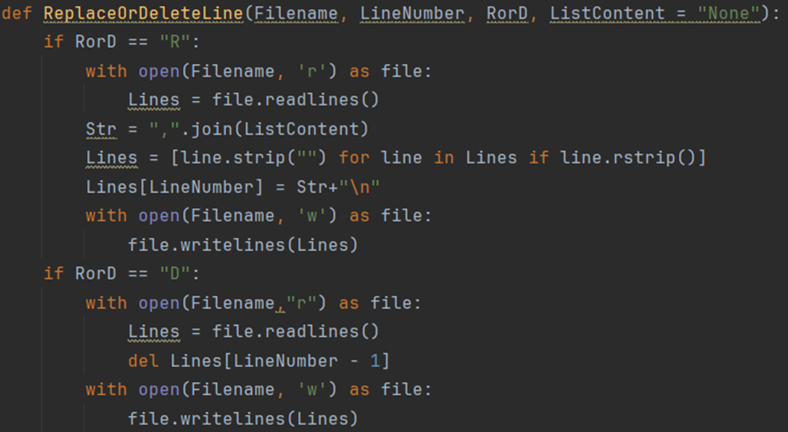

Figure 1. 1

This function is used to delete or replace a particular line(Line Number) data in the Filename. First, get the entire data from the file(file of Filename) select the LineNumber which is given and replace or delete it. In the end, rewrite the file's data with the content after the change.

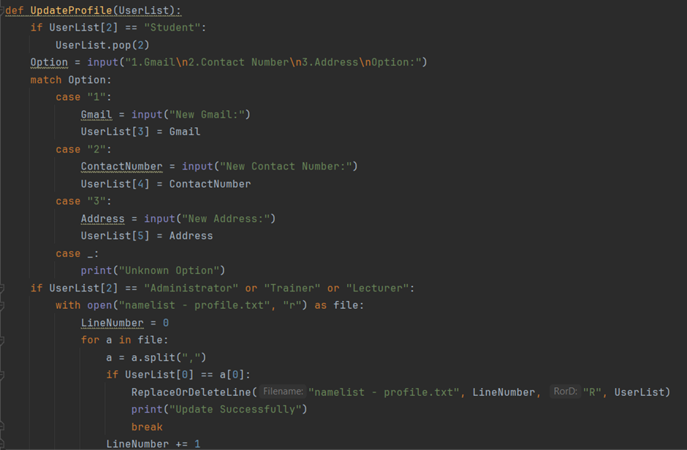  
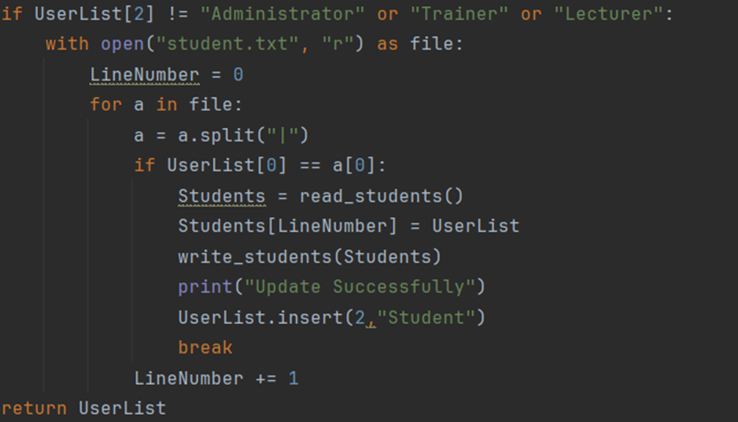

Figure 1. 2

This function is used to update the user profile. There are two text files in which “namelist – profile.txt” includes administrator, trainer and lecturer data and “student.txt” includes student data. They do the same thing, but it was separated because the format isn’t the same. First, select which data should be updated. It will replace the particular data with the new content written in by the user. At the end, replace the line from the file with the new line.

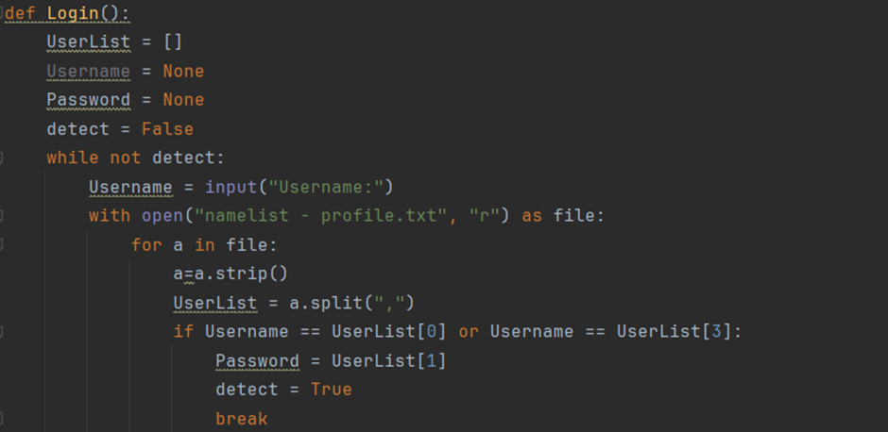

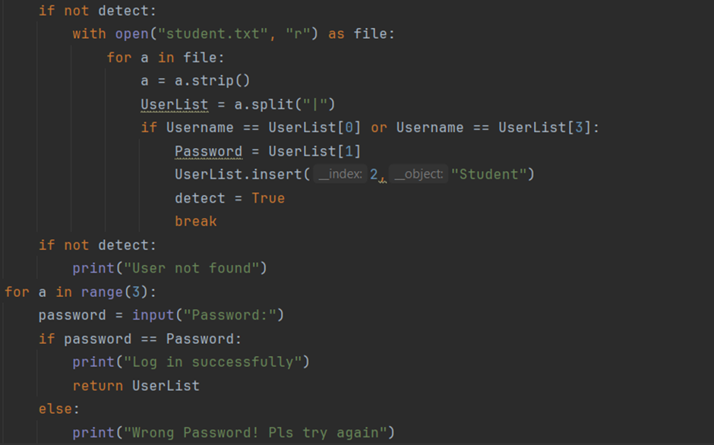

Figure 1. 3

This function is used to do the login part. There are two text files in which “namelist – profile.txt” includes administrator, trainer and lecturer data and “student.txt” includes student data. They do the same thing, but it was separated because the format isn’t the same. First, find the line of data according to the username which is written in. If the written username can’t be found, it will display the user not found and prompt the user for the username again. Once it is found, prompt the user for the password and three chances are given if the password is incorrect. Once the username and password are correct, it will return the data list.

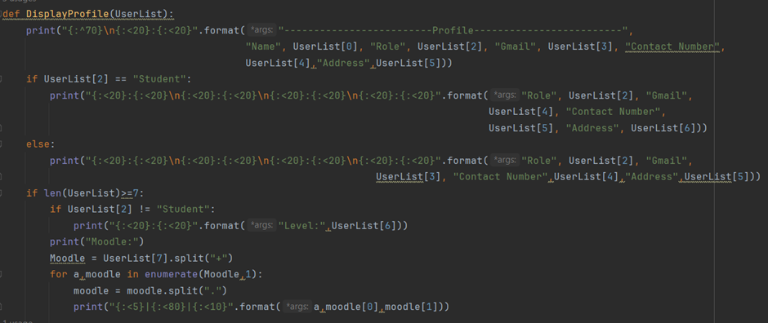

Figure 1. 4

This is the function to display the user profile who log in. Data such as username, role, Gmail, contact number and address will show in the display bar by the format. Level and module will be shown also if they exist.

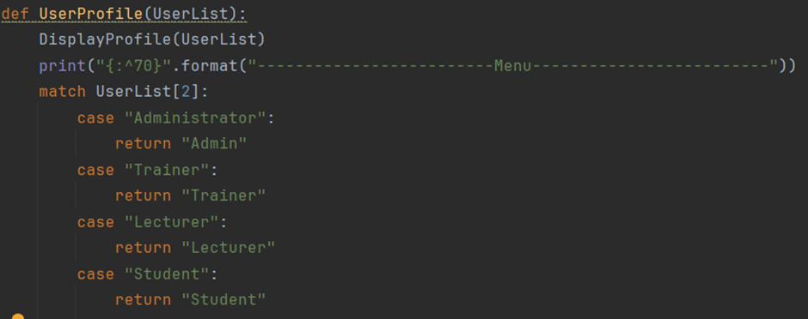

Figure 1. 5

The function will be called after log in. It will call the function to display the profile return the role name and the menu will be displayed according to the role who logged in.

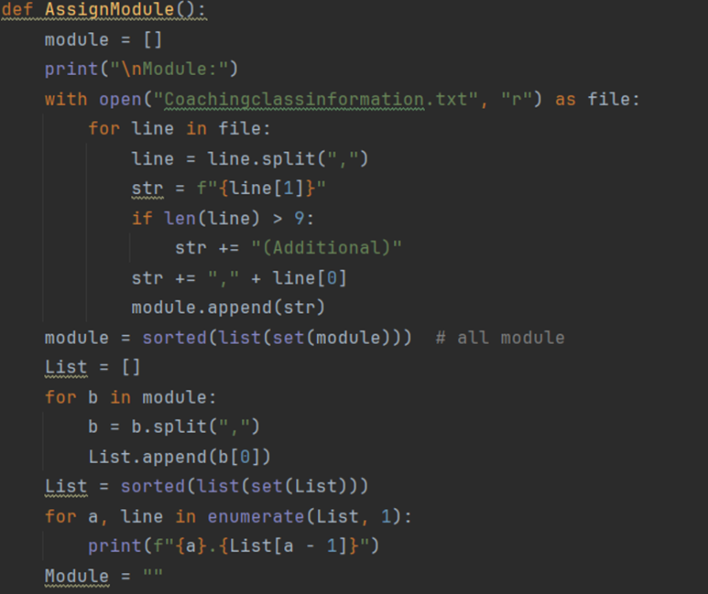

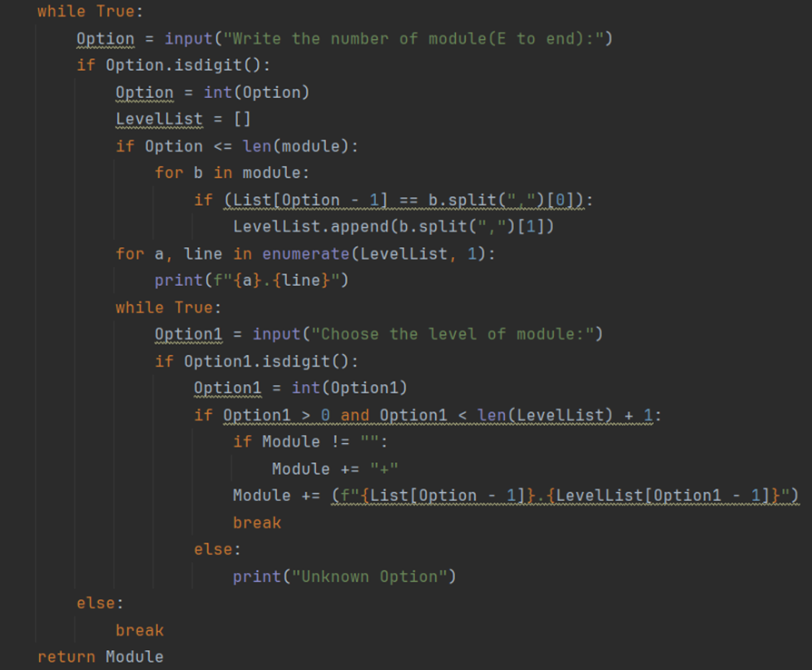

Figure 1. 6

This is the function that prompts the user to assign the lecturer module. First, it will get the data from “Coachingclassinformation.txt” and save it in the list “module”. It will show every module to the user and prompt the user to choose the module which they want. It will return the list “module” which includes the chosen module at the end.

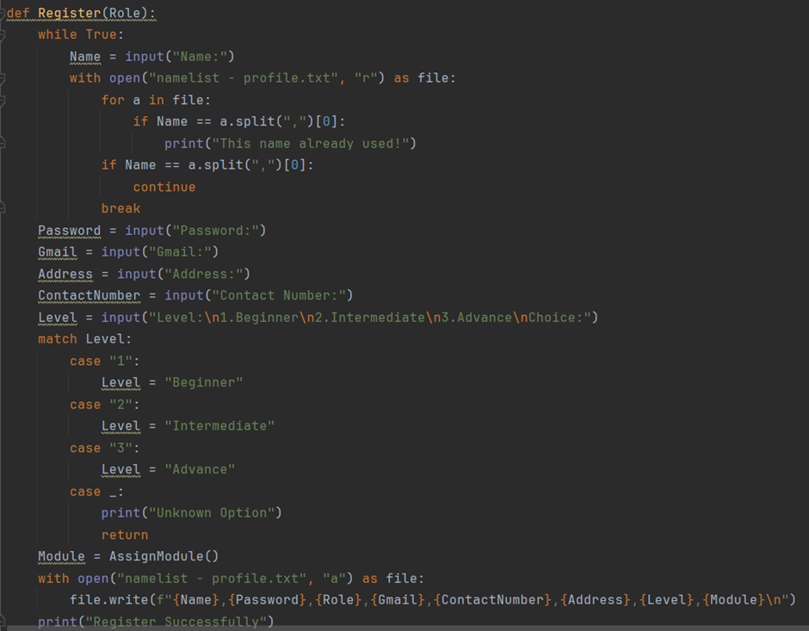

Figure 1. 7

According to the given role, this function will register a new role. The user should write in the new user details such as username, password, Gmail, address, contact number, level and the selected module which is returned by the function “AssignModule()”. Open the file in append mode and store the new user data in the file “namelist – profile.txt”.

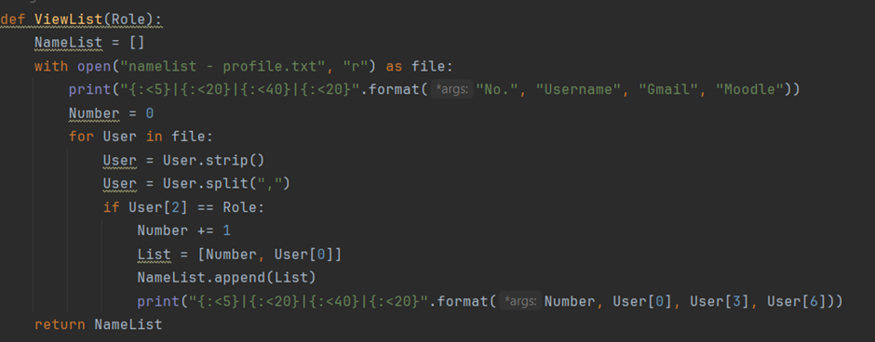

Figure 1. 8

This function will display a list of users with a specific role from “namelist – profile.txt”. It will display the list of users at the end and return the list.

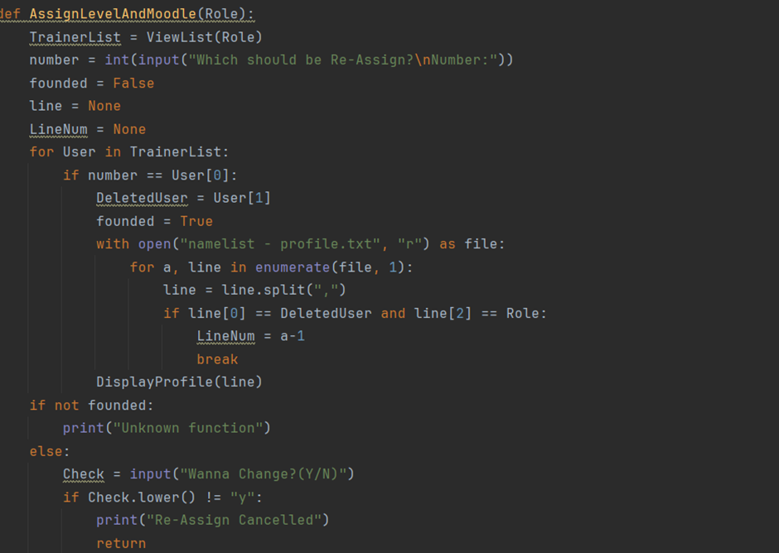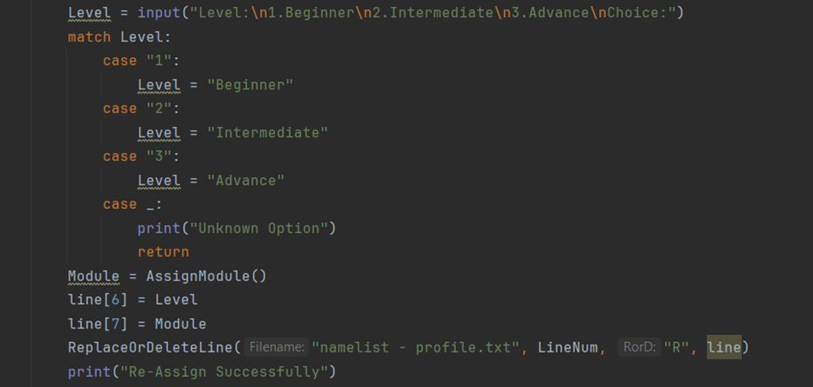

Figure 1. 9

This function is used to re-assign a user’s details. Level and module can be re-assigned by the way are given. First, it will Call ViewList() function to display the list with specific roles and return the namelist. Once the specific person is selected, prompt the user to choose a new level and new module by using the function “AssignModule()”.Call the function ”ReplaceOrDeleteLine()” to replace data at the end.

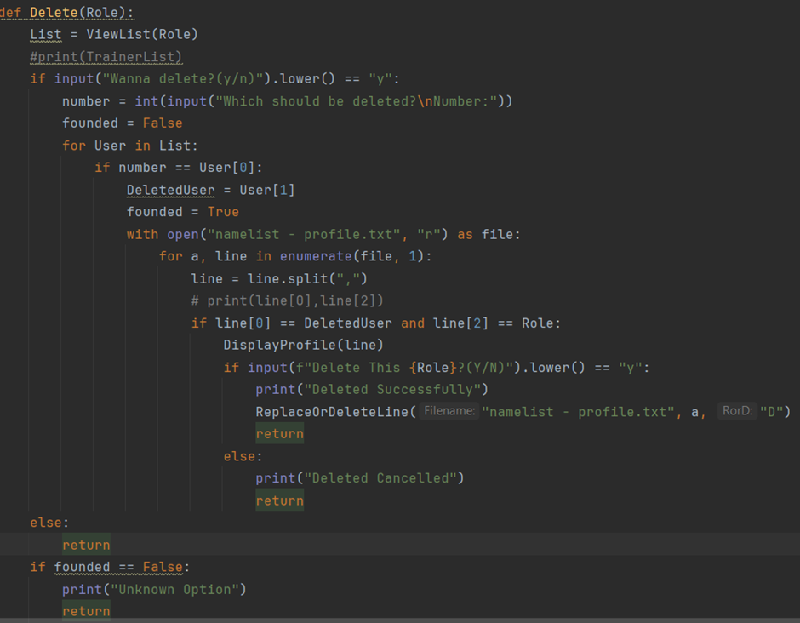

Figure 1. 10

The user is available to delete a user with a specific role. First, display a list with the specific role of the user. Users can select the user which should be deleted. It will display the user details by using the function “DisplayProfile” again. Users will be given a chance to make the final decision. Once the user confirms, the selected user will be deleted from the file by using the function “ReplaceOrDeleteLine”.

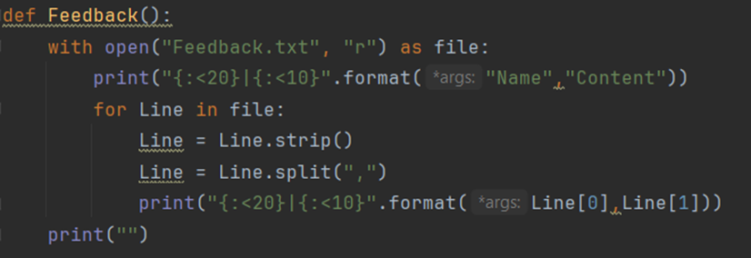

Figure 1. 11

This function is used to view feedback sent by the Trainer. It will display the name of the trainer and its feedback.

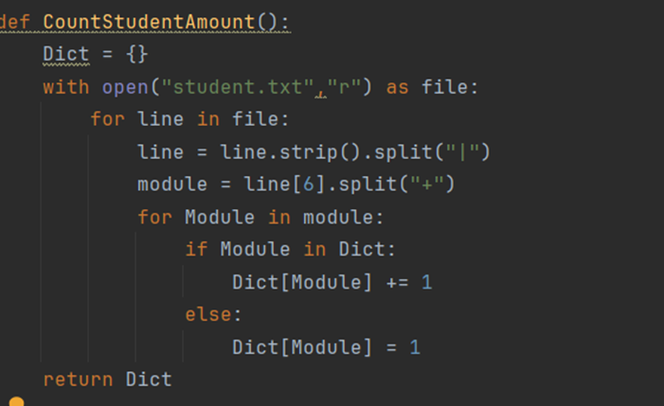

Figure 1. 12

This function is used to count the student amount against the module. It will open the file “student.txt” and count the student amount in the module. Return the dictionary at the end.

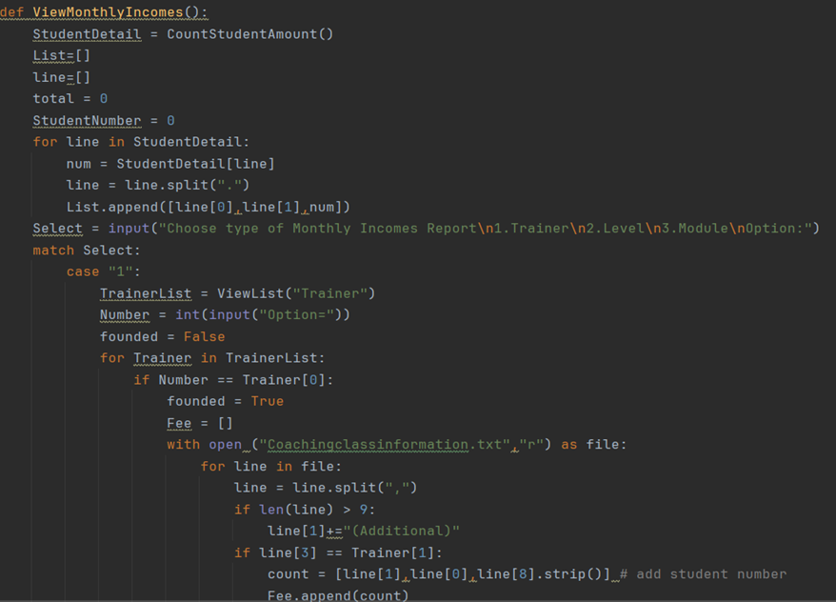

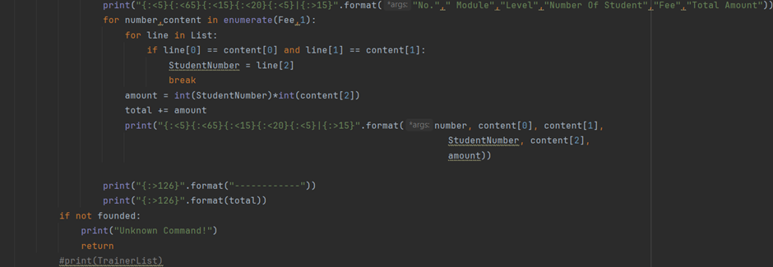

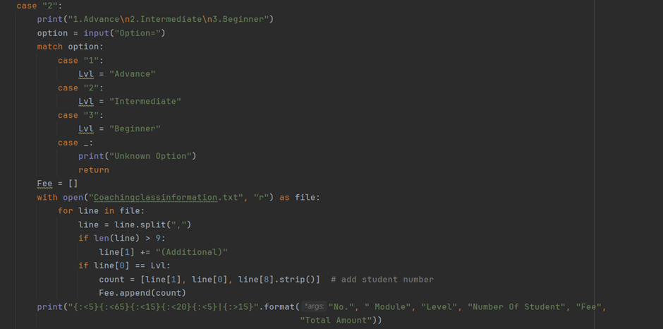

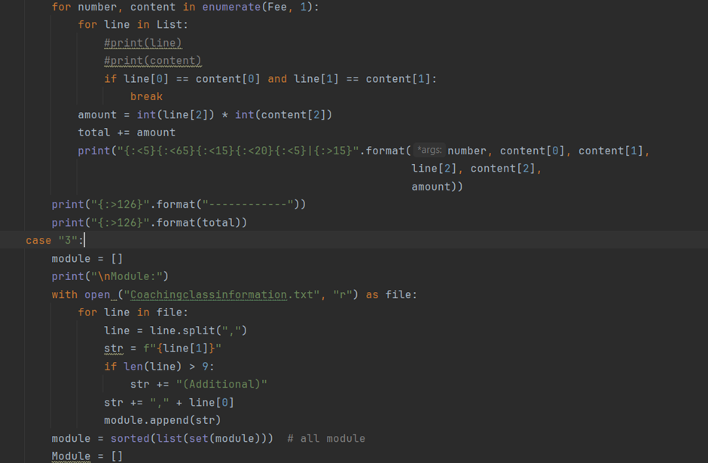

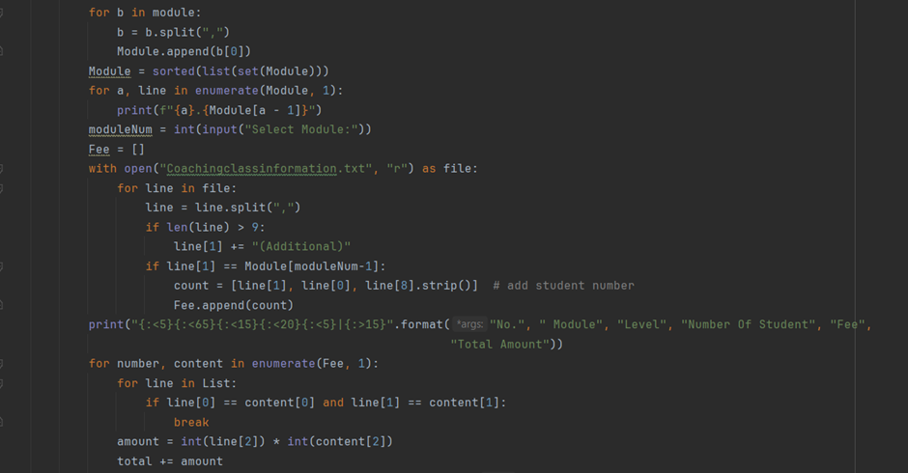

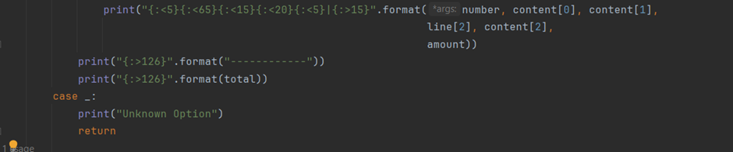

Figure 1. 13

This function is used to view the entire monthly income report for trainers, levels or modules. First, get the number of students for each module by using the function “CountStudentAmount()”. The list “count” included module name, level and fee. It will display the monthly income invoice and count the incomes of every class and total incomes based on the type of income.

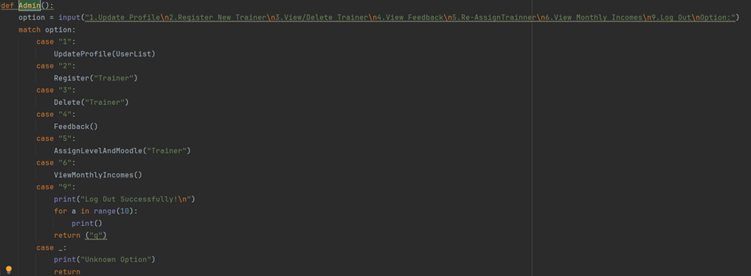

Figure 1. 14

This function is used to select the feature. Only the administrator has access to the function. The functionalities will be displayed, and the user can choose the function.   
The following are the functionalities provided:

1. Update Profile
2. Register New Trainer
3. View/Delete Trainer
4. View Feedback
5. Assign Trainer
6. View Monthly incomes
7. Log out

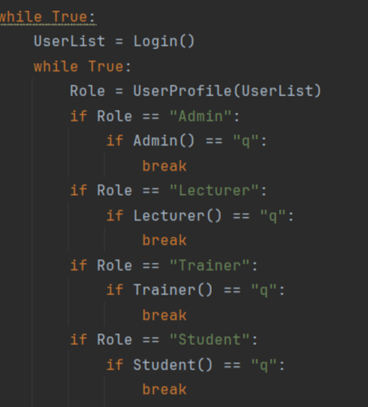

Figure 1. 15

This code is used to start calling the function “login”. It will call the role’s function according to the returned value. If the role’s function returns “q” then it will quit the role's function and log in again.

## Student2, Trainer (Manreen Kaur A/P Jagjit Singh, TP071290)

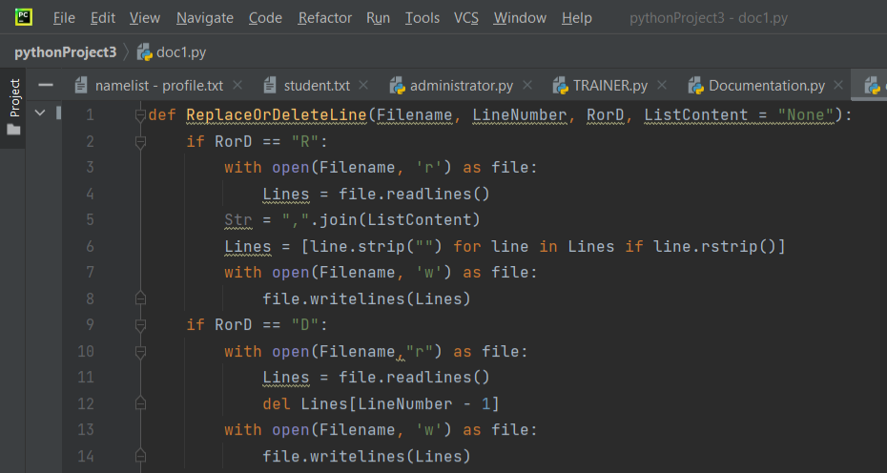

Figure 2. 1 Replace or Delete Line

The Trainer’s segment of ReplaceOrDeleteLine(Filename, LineNumber, RorD, ListContent = “None”): code applies numerous programming concepts. The explanation is provided below based on the specific code for a better understanding of Python programming concepts.

|  |  |  |
| --- | --- | --- |
| **Programming concept** | **Code** | **Clarification** |
| Function definition | def ReplaceOrDeleteLine(Filename, LineNumber, RorD, ListContent = “None”): | This code is stated as the function named **ReplaceOrDeleteLine**. This is a reclaimable block that enables to running of a specific duty and classification in a logical form of codes. This block grants the coder to label identity and indicate the parameters accepted which are name the file, line number, replace or delete, and replace content. This block allows the programmer to comprehend, manage and reapply. |
| Conditional Statement (Selection) | if RorD | The if statement is a construct permitting a system to create decisions based on certain circumstances.  The statement investigates circumstances if the user selects to replace **“R”** or delete **“D”** of a specific line. |
| File Processing | with open(Filename, “r”) and with open(Filename, “w”) | The **with open()** statement processes the file to open and close the file appropriately. The code reads the content in the file **“r”** whereas **“w”** opens the file in a write mode. |
| Reading and Writing Lines | Lines = file.readlines() and file.writelines(Lines) | **The Lines = file.readlines()** code reads all lines and reserves them in the **“Lines”** list. Whereas the **file.writelines(Lines)** write the lines back into the file. |
| String Manipulation | ",".join(ListContent) | This code transforms the characters in **ListContent** into a single comma separated string. The line.strip(“”) extracts the occurrences of leading and trailing of empty string line in lines and it trails whitespaces. |
| List Manipulation | Lines = [line.strip("") for line in Lines if line.rstrip()] | This comprehension list extracts empty lines from a list. |
| Deleting A Line | “D” | Eliminates specified line from **LineNumber**. The **del Lines[LineNumber – 1]** eliminates line from the list. |
| Default Parameter | ListContent = "None" | It is a default parameter function and if not provided then it will default the string as **“None”.** |
| Error Handling |  | Assume file exists and does not include error-handling mechanisms for the existence of file or valid **LineNumber**. |

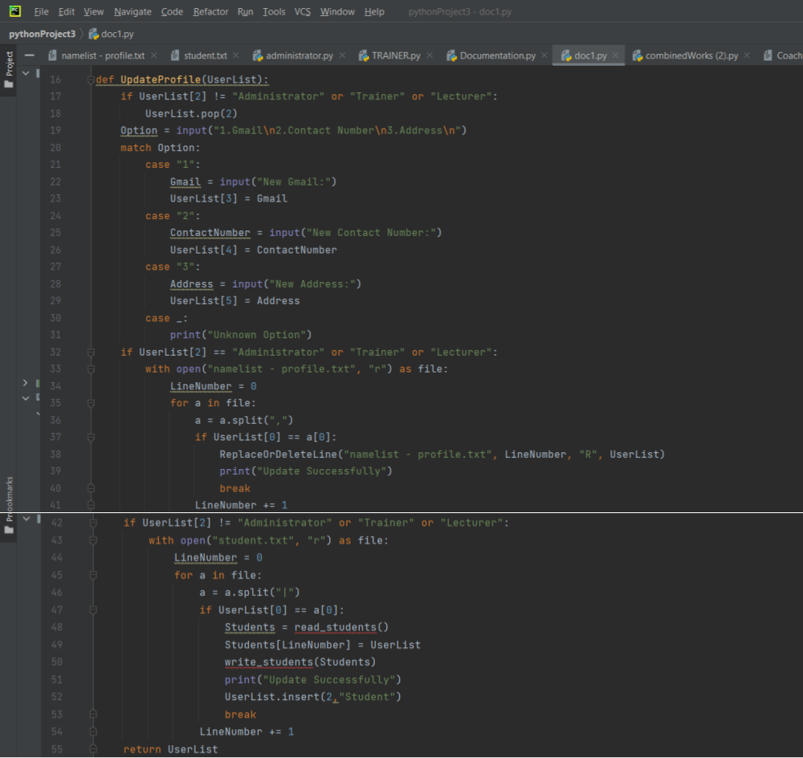

Figure 2. 2 Update Profile

The Trainer’s segment of UpdateProfile(UserList) code applies numerous programming concepts. The explanation is provided below based on the specific code for a better understanding of Python programming concepts.

|  |  |  |
| --- | --- | --- |
| **Programming concept** | **Code** | **Clarification** |
| Function definition | def UpdateProfile(UserList) | This code is stated as the function named **UpdateProfile**. This is a reclaimable block that enables to running of a specific duty and classification in a logical form of codes. This block grants the coder to label identity and indicate the parameters accepted which is the list parameter **UserList**. This block allows the programmer to comprehend, manage and reapply. |
| Conditional Statement (Selection) | if UserList[2] != "Administrator" or "Trainer" or "Lecturer": | The if statement is constructed permitting the system to create decisions based on certain circumstances.  The statement investigates circumstances if the user selects “Administrator” “Trainer” or “Lecturer”. Then it will jump to the next block based on the option chosen. |
| Input Function | Option = input("1.Gmail\n2.Contact Number\n3.Address\n")  Gmail = input("New Gmail:")  ContactNumber = input("New Contact Number:")  Address = input("New Address:") | This function is to prompt data from the user to update its profile. |
| Print Function | print("Update Successfully") | The message within the print statement is displayed on the console. This output is displayed for the user to view the result if it is updated successfully. |
| Switch Case (Match Statement) | match Option:  case "1":  # code for option 1  case "2":  # code for option 2  case "3":  # code for option 3  case _:  print("Unknown Option") | This code is to execute different branches of code based on the code value given. This option handles multiple possible conditions. The switch expression is evaluated once and compared against a list. Then the code branches to the corresponding case block and executes the duty. If none of the options is matched, then it will be printed as **Unknown Option**. |
| List Manipulation |  | The user list method like **insert()** manipulates the **UserList**. |
| File Processing | namelist - profile.txt and student.txt | The code reads and modifies these files by using I/O operations to open, read and write into the files. |
| Loops | for a in file:  # code inside the loop | This is to iterate the lines in the file to find relevant data. |
| Function Calls | ReplaceOrDeleteLine, read_students(), and write_students(). | This code is to call these functions in the system. |
| Logical Operators | != and or | These are conditional terms, **“!=”** means not equivalent whereas **“or”** means if one of the conditions is **“True”**. |
| Error Handling |  | Code doesn’t manage the errors explicitly and may have issues for **“or”** logical operator. |
| Data Handling |  | Reads and updates data related to **UserProfile** for instance, Gmail, Contact Number and Address. |

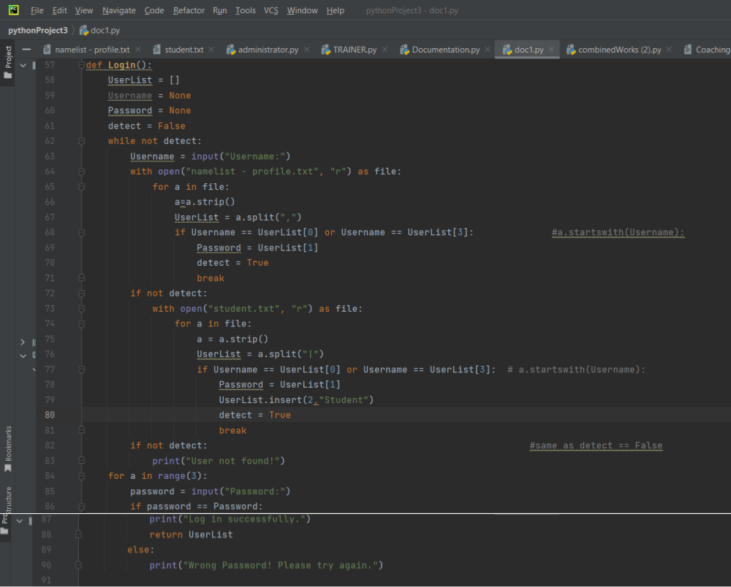

Figure 2. 3 Login

The Trainer’s segment of Login code applies numerous programming concepts. The explanation is provided below based on the specific code for a better understanding of Python programming concepts.

|  |  |  |
| --- | --- | --- |
| **Programming concept** | **Code** | **Clarification** |
| Function definition | def Login(): | This code is stated as the function named **Login**. This is a reclaimable block that enables to running of a specific duty and classification in a logical form of codes. This block grants the coder to label identity and indicates the parameters accepted which is for the user to log in to the system. This block allows the programmer to comprehend, manage and reapply. |
| User Input(input()) | Username = input("Username:") | This code is to prompt from user username and password. |
| Print Function(print()) | print("User not found!")  print("Wrong Password! Please try again.")  print("Log in successfully.") | The message within the print statement is displayed on the console. This output is displayed for the user to view the result if it is **“User not found!”** or **“Wrong Password! Please try again.”** or **“Log successfully”.** |
| Loops(while and for) | while not detect:  # code inside the while loop  for a in range(3):  # code inside the for loop | To prompt from user for username repeatedly until a valid user is found, the coder implied the **while** statement. To limit the loop statement the coder utilized **for** statement in the program. |
| File processing | with open("namelist - profile.txt", "r") as file:  # code inside the first file processing block | The code reads these files **namelist - profile.txt** and **student.txt** to check the validity of username and password. This code also implies **with open()** statement for a sufficient file processing. |
| List Manipulation | UserList = a.split(",") and  UserList = a.split("|") | To reserve data retrieved from text files, the coder utilized lists **“UserList”**. |
| Conditional Statement (Selection) | if Username == UserList[0] or Username == UserList[3]:  if not detect:  if password == Password: | The if statement is utilized to inspect situations and control the system’s flow. |
| Break Statement | break | This statement is exploited to end the loop when a valid user is found. |
| Default Values(None) | Username = None and Password = None | These statements are exploited before the loop so that the user may enter their data. |
| Return Statement | return Userlist | This code is to return **UserList** when the login is successful. |

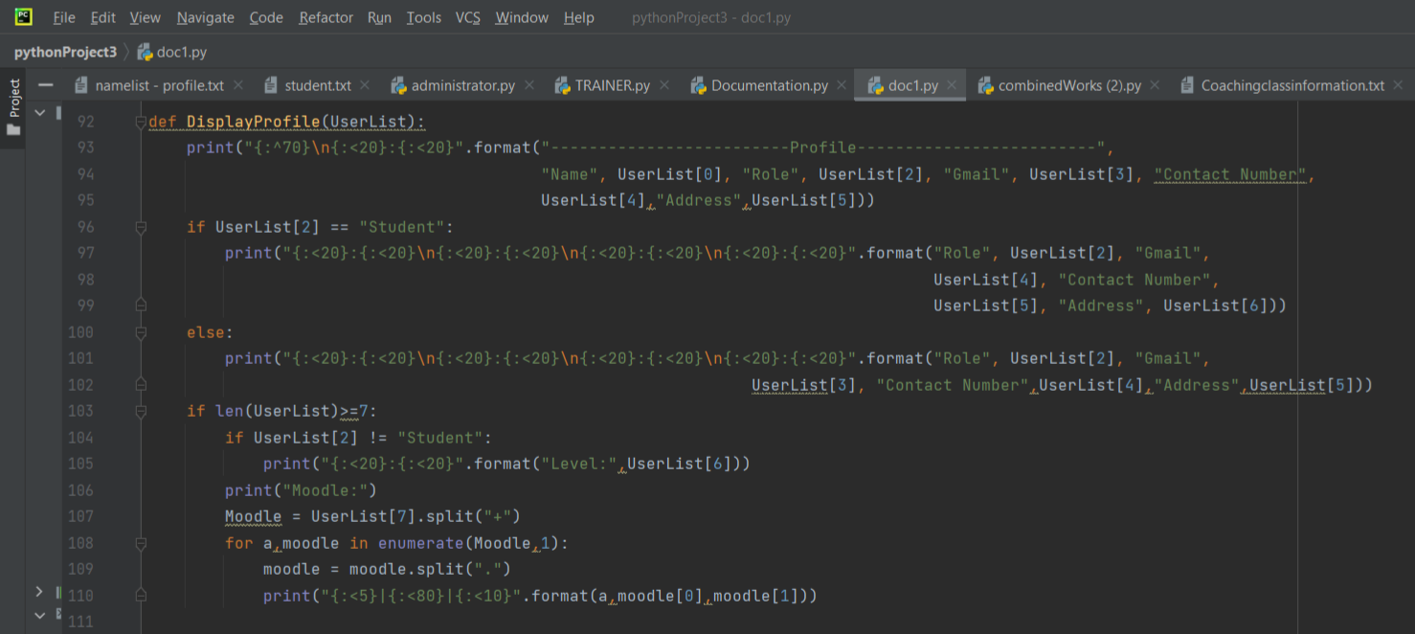

Figure 2. 4 Display Profile

The Trainer’s segment of DisplayProfile(UserList) code applies numerous programming concepts. The explanation is provided below based on the specific code for a better understanding of Python programming concepts.

|  |  |  |
| --- | --- | --- |
| **Programming concept** | **Code** | **Clarification** |
| Function definition | def DisplayProfile(UserList): | This code is stated as the function named **DisplayProfile**. This is a reclaimable block that enables to running of a specific duty and classification in a logical form of codes. This block grants the coder to label identity and indicates the parameters accepted which is to display profile. This block allows the programmer to comprehend, manage and reapply. |
| Print Function(print()) | print("{:^70}\n{:<20}:{:<20}".format("-------------------------Profile-------------------------",  "Name", UserList[0], "Role", UserList[2], "Gmail", UserList[3], "Contact Number",  UserList[4],"Address",UserList[5])) | The message within the print statement is displayed on the console. This output is displayed for the user to view the result if it is **“Gmail”** or **“Contact Number”** or **“Phone Number”.** |
| String Formatting(format()) | "{:^70}\n{:<20}:{:<20}".format("-------------------------Profile-------------------------",  "Name", UserList[0], "Role", UserList[2], "Gmail", UserList[3], "Contact Number",  UserList[4],"Address",UserList[5]) | This format is applied to authorize dynamic insert of values for formatted string. |
| Conditional Statement(Selection) | if UserList[2] == "Student":  # code inside the if block  else:  # code inside the else block | The if statement is utilized to inspect situations and control the system’s flow. |
| String Concatenation | "{:<20}:{:<20}\n{:<20}:{:<20}\n{:<20}:{:<20}\n{:<20}:{:<20}".format("Role", UserList[2], "Gmail",  UserList[4], "Contact Number",  UserList[5], "Address", UserList[6]) | This format constructed to combine multiple strings. |
| List Manipulation | UserList[0], UserList[2], UserList[3], UserList[4], UserList[5], UserList[6], UserList[7] | The code accesses and manipulates values into the list **UserList**. |
| Enumeration(enumerate()) | for a, moodle in enumerate(Moodle, 1):  # code inside the for loop | This function is to obtain the index and the value from the iteration over the lines in the file with the sequence and index. Concurrently tracks the index of every unit and results as an enumerate object that pairs with indices and values that terminates additional index variable maintenance. |
| String Splitting | moodle.split("+"), moodle.split(".") | This procedure is applied to split strings into the list of substrings. |
| String Length(len()) | if len(UserList) >= 7:  # code inside the if block | The **len()** function is to examine of the list **UserList**. |
| Formatted Output |  | The program implied formatted output to align and present data in a structure. |

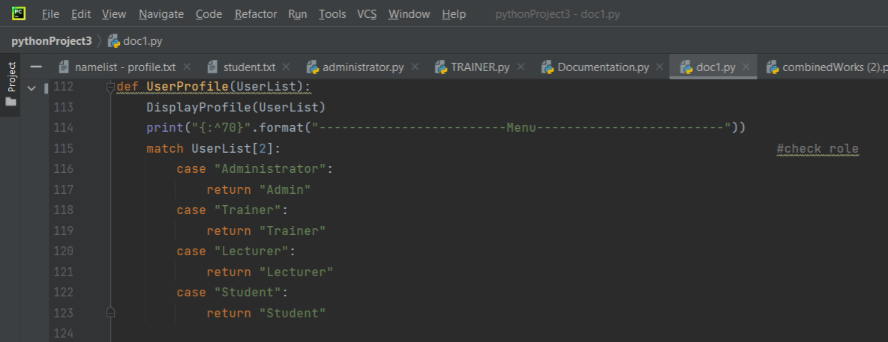

Figure 2. 5 User Profile

The Trainer’s segment of UserProfile(UserList) code applies numerous programming concepts. The explanation is provided below based on the specific code for a better understanding of Python programming concepts.

|  |  |  |
| --- | --- | --- |
| **Programming concept** | **Code** | **Clarification** |
| Function definition | def UserProfile(UserList): | This code is stated as the function named **UserProfile**. This is a reclaimable block that enables to running of a specific duty and classification in a logical form of codes. This block grants the coder to label identity and indicates the parameters accepted which is the user’s profile. This block allows the programmer to comprehend, manage and reapply. |
| Function Call | DisplayProfile(UserList) | This code calls DisplayProfile which is to exhibit the user’s profile. |
| Print Function(print()) | print("{:^70}".format("-------------------------Menu-------------------------")) | The message within the print statement is displayed on the console. This output is displayed for the user to view the menu. |
| String Formatting(format) | "{:^70}".format("-------------------------Menu-------------------------") | This format is applied to authorize dynamic insert of values for formatted string. |
| Switch Case(Match Statement) | match UserList[2]:  case "Administrator":  return "Admin"  case "Trainer":  return "Trainer"  case "Lecturer":  return "Lecturer"  case "Student":  return "Student" | This code is to execute switch-like case selection. This option handles multiple possible conditions based on user’s role. The switch expression is evaluated once and compared against a list. Then the code branches to the corresponding case block and executes the duty. |
| Return Statement | return "Admin" # or "Trainer", "Lecturer", "Student" based on the role | This code appoints the user’s role which are either **“Administrator”, “Trainer”, “Lecturer”, or “Student”**. |
| Code organization |  | It is a structured approach that presents user’s profile first and then the role based on switch-like structure user’s role. |
| String Centering(^) | format("{:^70}") | The **“^”** midpoints within 70 characters. |

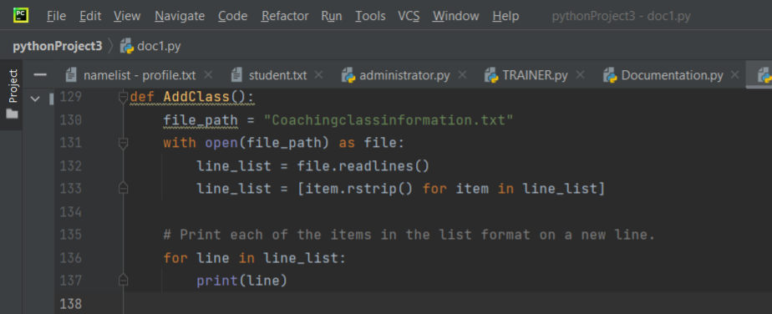

Figure 2. 6 Add Class

The Trainer’s segment of AddClass() code applies numerous programming concepts. The explanation is provided below based on the specific code for a better understanding of Python programming concepts.

|  |  |  |
| --- | --- | --- |
| **Programming concept** | **Code** | **Clarification** |
| Function definition | def AddClass(): | This code is stated as the function named **AddClass**. This is a reclaimable block that enables to running of a specific duty and classification in a logical form of codes. This block grants the coder to label identity and indicates the parameters accepted. This block allows the programmer to comprehend, manage and reapply. |
| File Processing | file_path = "Coachingclassinformation.txt"  with open(file_path) as file:  # code inside the with block | The code reads these files **Coachingclassinformation.txt** reads the information in this file using I/O operations. This code also implies **with open()** statement for a sufficient file processing of resources and terminates automatically the block when exit. |
| List Comprehension | line_list = [item.rstrip() for item in line_list] | The function of this code is to strip new line characters using (“n\”) for the lines read by the file. |
| Looping(for Loop) | for line in line_list:  print(line) | The code utilized **“for”** loop to iterate each line in **“line_list”** and print it. |
| Print Function(print()) | print(line) | The message within the print statement is displayed on the console. This output is displayed for the user to view the menu. |
| String Stripping (rstrip()) | line_list = [item.rstrip() for item in line_list] | This procedure is implemented to trail whitespaces characters including newline characters from each line. |
| Variable Assignment | file_path | The file_path is assigned to “Coachingclassinformation.txt” |
| Code organization |  | It is a coordinated design that read, process, and the prints lines from the file. |

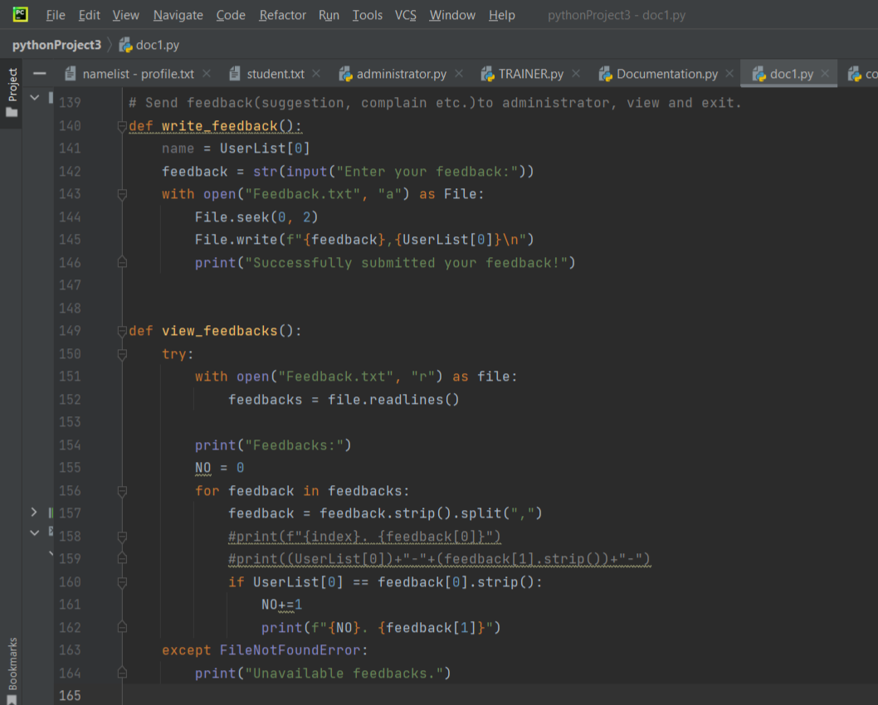

Figure 2. 7 Write and View Feedback

The Trainer’s segment of write_feedback() and viewfeedback() code applies numerous programming concepts. The explanation is provided below based on the specific code for a better understanding of Python programming concepts.

|  |  |  |
| --- | --- | --- |
| **Programming concept** | **Code** | **Clarification** |
| Function definition | def write_feedback(): and view_feedback(): | This code is stated as the function named **write_feedback and view_feedback**. This is a reclaimable block that enables to running of a specific duty and classification in a logical form of codes. This block grants the coder to label identity and indicates the parameters accepted which are to write and view feedback. This block allows the programmer to comprehend, manage and reapply. |
| User Input(input()) | feedback = str(input("Enter your feedback:")) | This code is to obtain input from the user for feedback. |
| Print Function(print()) | print("Successfully submitted your feedback!") | The message within the print statement is displayed on the console. This output is displayed for the user to view their own feedback(s). |
| File Processing(Writing to a file) | with open("Feedback.txt", "a") as File:  File.seek(0, 2)  File.write(f"{feedback},{UserList[0]}\n") | The code reads the **write_feeback()** function to open **Feedback.txt** in the append mode **“a”**. In the file, it will print the feedback and the user’s name. |
| File Processing(Reading from a file) | with open("Feedback.txt", "r") as file:  feedbacks = file.readlines() | The code reads the **view_feeback()** function to open **Feedback.txt** in the append mode **“r”**. It will read the file that saves the user’s feedback(s). |
| Exception Handling(try-except) | try:  # code inside the try block  except FileNotFoundError:  print("Unavailable feedbacks.") | This block handles errors or exceptions that potentially occur when executed. The exceptions interrupt the system that may be due to invalid input or unavailable files “**FileNotFoundError”** and are expected to have exceptions. The try code consists of the code desired to execute. If the input is within the except block, it will print **“Unavailable feedback”**. Exceptions can be found using the names or generic Exception class. Try-Except code avoids errors existing in the system. |
| Looping for Loop | for feedback in feedbacks:  # code inside the for loop | The code utilized **“for”** loop to iterate each feedback and print it if matches. |
| List Manipulation | feedback = feedback.strip().split(",") | The code utilizes list manipulates to split and extract data from feedback lines. |
| Conditional Statement (Selection) | if UserList[0] == feedback[0].strip(): | The if statement is utilized tin view_feedback() to inspect situations if current feedback associated with current user. |
| Variable Assignment | name and feedback | The name and feedback are assigned to UserList and the user’s input. |
| Code organization |  | The code organizes function for modularization and reusability. |
| Handling Multiple Data Types | (`charges = int(input("Enter the charges: "))`)    `ValueError` | This code attempts to convert the user’s input into the integer format and control the potential exceptions if the conversion fails. |

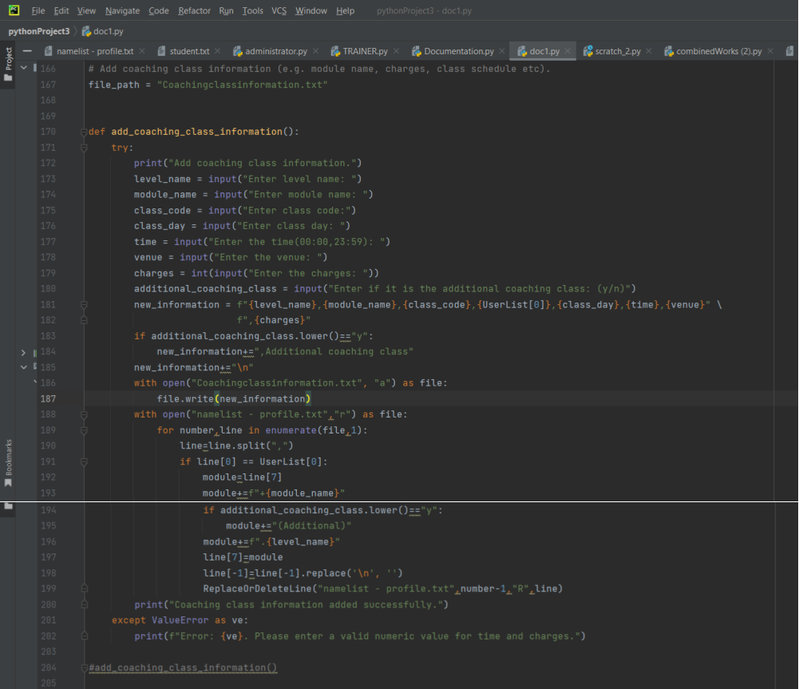

Figure 2. 8 Add Coaching Class Information

The Trainer’s segment of adding coaching class information (module, charges, class schedule, etc.) code applies numerous programming concepts. The explanation is provided below based on the specific code for a better understanding of Python programming concepts.

|  |  |  |
| --- | --- | --- |
| **Programming concept** | **Code** | **Clarification** |
| Function definition | def add_coaching_class_information(): | This code is stated as the function named add_coaching_class_information(). This is a reclaimable block that enables to run a specific duty and classify in a logical form of codes. This block grants coder to label identity and indicate the parameters accepted. This block allow programmer to comprehend, manage and reapply. |
| Try-Except Block (Exception Handling) | try:  # code that may raise an exception  except ValueError as ve:  # handle the exception | This block handles errors or exceptions that potentially occur when executed. The exceptions interrupt the system that may be due to invalid input or unavailable files and are expected to have exceptions. The try code consists of the code desired to execute. If the input is within the except block, it will jump to the following except code to manage it. Exceptions can be found using the names or generic Exception class. Try-Except code avoids errors existing in the system. |
| Printing to console | print("Add coaching class information.") | The message within the print statement is displayed on the console. This output is displayed for the user or for the coder to debug by producing values, messages, or data to the terminal or command prompt. |
| User input(input(function) | level_name = input("Enter level name: ") | This function is to prompt data from the user and the data will be stored in variables like level_name, level_module, etc in the run time and wait till the user submits an input. Then, the input is returned as a string. To implement numeric operations on the input, the programmer has to code appropriate data types for instance int() for an integer or float() for a floating point number. |
| Conditional statement (if statement) | if additional_coaching_class.lower()=="y":  # code to be executed if the condition is true | The if statement is constructs permitting system to create decisions based on certain circumstances.  The statement investigates circumstances if it is the Boolean expression that is “True” or “False”. The “True” condition will be executed whereas the “False” condition skips the program to the next block. |
| String concatenation | new_information = f"{level_name},{module_name},{class_code},...,{charges}" | It is a technique to assemble by merging many strings into a single string. To concatenate the strings, a programmer should utilize f”{},{},{},...”. |
| File input/output (Reading and writing to a File) | with open("Coachingclassinformation.txt", "a") as file:  file.write(new_information) | The code opens and writes to different text files using the same input that was obtained from the user. The procedure of reading data from the files (input) and writing data to files (output) authorizes the system to interact with external files accumulated in the disk. The open() function is written before reading and coding to the files for file_path and mode. The mode integrated into the code is “a” as the append mode. |
| Enumeration(enumerate()function) | for number, line in enumerate(file, 1):  # code that uses 'number' and 'line' | This function is to obtain the index and the value from the iteration over the lines in the file. It is known as the built-in function to approve looping for iterable, for instance, list, tuple, or string. Concurrently tracks the index of every unit and results as an enumerate object that pairs with indices and values that terminates additional index variable maintenance. |
| List Manipulation (split()method) | line = line.split(",") | Based on (“,”) delimiter, this is a method to split a string into a list of substrings. The delimiter specifies where the original string breaks apart. |
| Updating List Elements | line[7] = module | This code updates the determined component of the list. Specifying the line number wished to replace or update in the list is called an index that begins with 0 to the new value stored in the module variable. |
| String replacement | line[-1] = line[-1].replace('\n', '') | The replace() procedure is employed to replace a substring into a string. To replace the newline code (`’n\’`) with the last text of the `line` in an empty string. The line[-1] approaches the last text of `line`. The replace (‘n\’,’’) is a string technique to restore occurrences of the substring that replaces the newline character (‘n\’,’). |
| Calling an external function (ReplaceOrDeletreLine) | ReplaceOrDeleteLine("namelist - profile.txt", number - 1, "R", line) | This function is exploited for the user to replace or delete a specific line in a file. This code is to generate adjustments or modify contents in the text file. The namelist – profile.txt is the file name whereas the number-1 is an integer presented as the line number. “R” represents a string called for the function to make replacement in the file. `line` is the list of values to replace the specified line. |
| Printing Formatted Messages | print("Coaching class information added successfully.") | The message within the print statement is displayed on the console. This output is displayed for the user to view the result if it is successful. |
| Commented Code | (`#add_coaching_class_information()`) | This function is called at other parts of the system that are being utilized by the lecturer and students. This function allows lecturers and students to view the list of coaching class information organized by the trainer. |

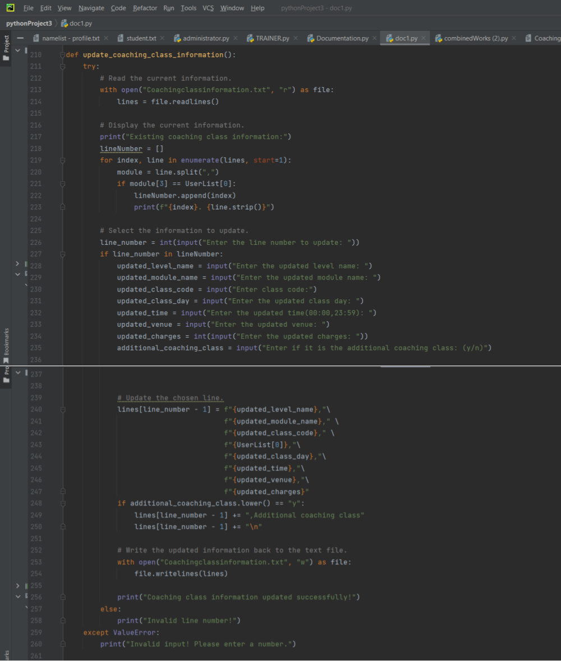

Figure 2. 9 Update Coaching Class Information

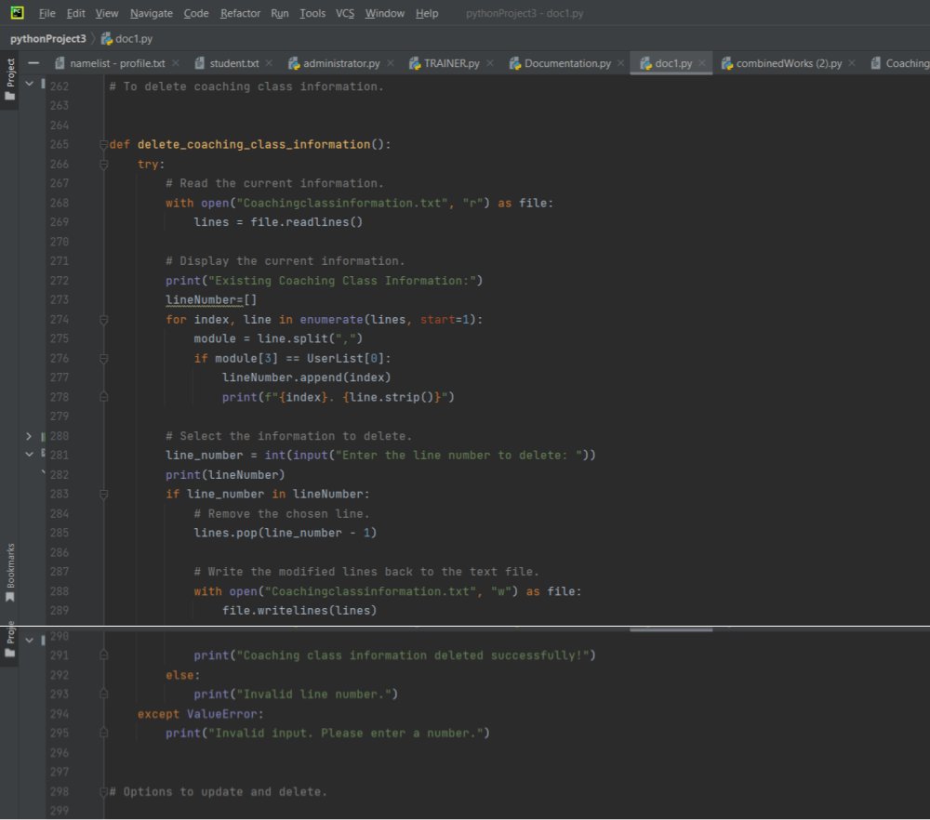

Figure 2. 10 Delete Coaching Class Information

The Trainer’s segment of update_coaching_class_information() and delete_coaching_class_information()code applies numerous programming concepts. The explanation is provided below based on the specific code for a better understanding of Python programming concepts.

|  |  |  |
| --- | --- | --- |
| **Programming concept** | **Code** | **Clarification** |
| Function definition | def update_coaching_class_information(): and delete_coaching_class_information(): | This code is stated as the function named **update_coaching_class_information and delete_coaching_class_information**. This is a reclaimable block that enables to running of a specific duty and classification in a logical form of codes. This block grants the coder to label identity and indicates the parameters accepted which are to update and delete coaching class information. This block allows the programmer to comprehend, manage and reapply. |
| File Processing(Reading from a file) | with open("Coachingclassinformation.txt", "r") as file:  lines = file.readlines() | To update and delete coaching class information, starts by reading from **“Coachingclassinformation.txt”** in reading mode **“r”**. It will read the file that saves the user’s coaching class information. |
| Looping from Loop | for index, line in enumerate(lines, start=1):  # code inside the for loop | To update and delete, utilizes **“for”** loop to iterate each line in file and print **(“Existing coaching class information”)**. |
| User Input(input()) | line_number = int(input("Enter the line number to update: ")) | Each function obtains input from the user line number and the updated information. |
| String Formatting() | lines[line_number - 1] = f"{updated_level_name}," \  f"{updated_module_name}," \  f"{updated_class_code}," \  f"{UserList[0]},"\  f"{updated_class_day},"\  f"{updated_time},"\  f"{updated_venue},"\  f"{updated_charges}" | The code applied f-string to generate a formatted string that displays updated string information. |
| Condition Statement(Selection) | if line_number in lineNumber: | The if statement is utilized in both functions to inspect situations if current line is valid. |
| List Manipulation | lines.pop(line_number - 1) | The code employs list manipulation to update (or delete) the chosen line. |
| File Processing (Writing to a file) | with open("Coachingclassinformation.txt", "w") as file:  file.writelines(lines) | After updating or deleting the chosen line, the function modifies based on the modification made by the user in the **“Coachingclassinformation.txt”**. The **“w”** means write. |
| Exception Handling (try-except) | try:  # code inside the try block  except ValueError:  print("Invalid input. Please enter a number.") | Both functions employed this code, this block handles errors or exceptions that potentially occur when executed. The exceptions interrupt the system that may be due to value error and are expected to have exceptions. The try code consists of the code desired to execute. If the input is within the except block, it will print **“Invalid input. Please enter a number”**. Exceptions can be found using the names or generic Exception class. Try-Except code avoids errors existing in the system. |
| Code organization |  | The code organizes function for modularization and reusability. |

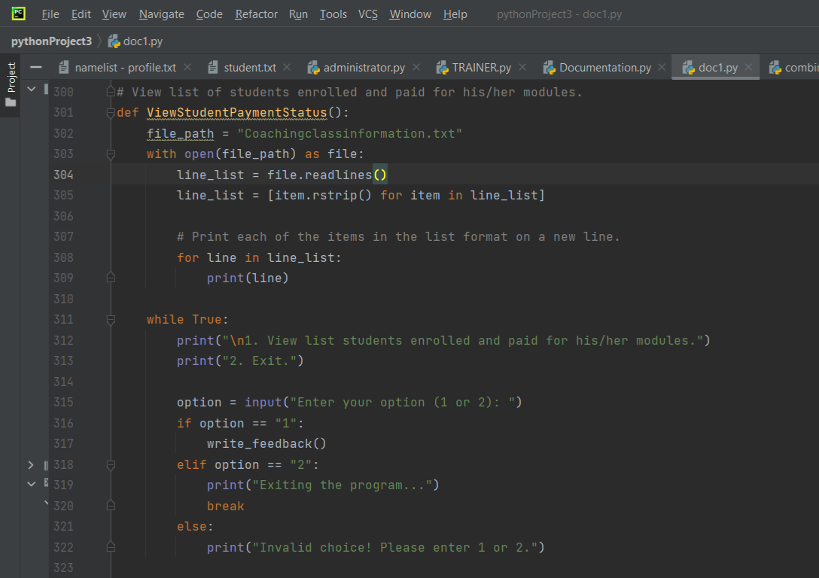

Figure 2. 11 View Student's Payment Status

The Trainer’s segment of ViewStudentPaymentStatus(): code applies numerous programming concepts. The explanation is provided below based on the specific code for a better understanding of Python programming concepts.

|  |  |  |
| --- | --- | --- |
| **Programming concept** | **Code** | **Clarification** |
| Function definition | def ViewStudentPaymentStatus(): | This code is stated as the function named **ViewStudentPaymentStatus():**. This is a reclaimable block that enables to running of a specific duty and classification in a logical form of codes. This block grants the coder to label identity and indicates the parameters accepted which are to view the student’s payment status. This block allows the programmer to comprehend, manage and reapply. |
| File Processing(Reading from a file) | file_path = "Coachingclassinformation.txt"  with open(file_path) as file:  line_list = file.readlines() | To view student’s payment status, the procedure starts by reading from **“Coachingclassinformation.txt”** in reading mode **“r”**. It will read the file into a list named **line_list**. |
| List Comprehension | line_list = [item.rstrip() for item in line_list] | It exploits list comprehension to strip newline characters **(“n\”)** the lines that was read by the file. |
| Looping for Loop | for line in line_list:  print(line) | To view the student’s payment status, it utilizes **“for”** loop to iterate each line in **line_list** and print it. |
| User Input(input()) | option = input("Enter your option (1 or 2): ") | The function obtains input from the user for menu option. |
| Conditional Statement(Selection) | if option == "1":  write_feedback()  elif option == "2":  print("Exiting the program...")  break  else:  print("Invalid choice! Please enter 1 or 2.") | The code **if, elif, and else** statement examine user’s selection and take suitable measurements. |
| Function call(write_feedback) | if option == "1":  write_feedback() | The code calls **write_feeback()** function if user selects **“1”** option. |
| Looping while Loop | while True:  # code inside the while loop | The **while** loop statement is to prompt from user endlessly until user chooses option **“2”** which is to exit. |
| Code organization |  | The code organizes function for modularization and reusability. |

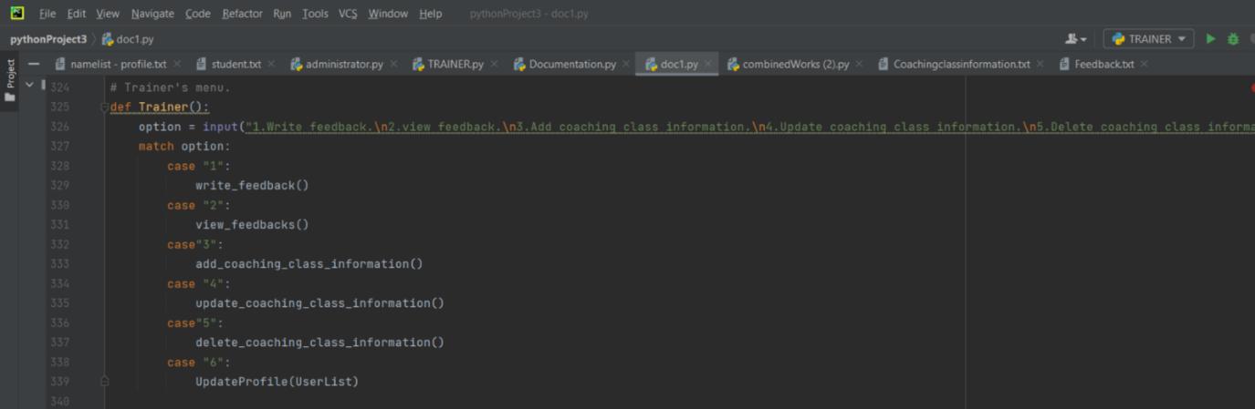

Figure 2. 12 Trainer's Menu

The Trainer’s segment of Trainer(): code applies numerous programming concepts. The explanation is provided below based on the specific code for a better understanding of Python programming concepts.

|  |  |  |
| --- | --- | --- |
| **Programming concept** | **Code** | **Clarification** |
| Function definition | def Trainer(): | This code is stated as the function named **Trainer():**. This is a reclaimable block that enables to running of a specific duty and classification in a logical form of codes. This block grants the coder to label identity and indicates the parameters accepted which serves as menu for the trainer. This block allows the programmer to comprehend, manage and reapply. |
| User Input(input()) | option = input("1.Write feedback.\n2.view feedback.\n3.Add coaching class information.\n4.Update coaching class information.\n5.Delete coaching class information.\n6.Update Profile.") | This code applies input() to obtain input from the user for menu option. |
| String Formatting | "1.Write feedback.\n2.view feedback.\n3.Add coaching class information.\n4.Update coaching class information.\n5.Delete coaching class information.\n6.Update Profile." | This format is applied to reveal the menu option to the user. |
| Conditional Statement(Selection) | match option:  case "1":  write_feedback()  case "2":  view_feedbacks()  # ... (similar cases for other options) | The **match** statement applied to match choices of user’s input to distinct cases and jump for the corresponding action. |
| Function Calls | case "1":  write_feedback() | Based on the user’s option, the program calls distinct functions to perform the selected task. |
| Code Organization |  | The system serves trainer’s menu and perform numerous jobs with the coaching class information system. |

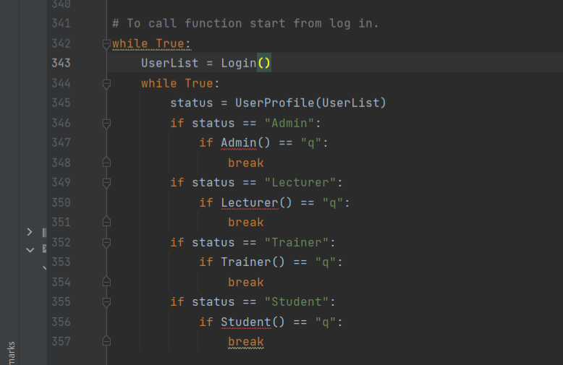

Figure 2. 13 Call function to log in

This Trainer’s segment code applies numerous programming concepts. The explanation is provided below based on the specific code for a better understanding of Python programming concepts.

|  |  |  |
| --- | --- | --- |
| **Programming concept** | **Code** | **Clarification** |
| Infinite loop | while True | This code is an infinite loop to interact endlessly with the user until the loop is broken. |
| Function calls | (Login(), User(), Admin(), Trainer(), Lecturer(), Student()): | The **Login()** function is to control user’s authentication. After logging in successfully, the system proceed to the next loop which is the **UserProfile()** function to present the user’s profile and it’s role. Based on the user’s role, the system will call its specific function which maybe Admin(), Trainer, Lecturer(), or Student(). |
| Nested Loops | while True within while True | This nested loop is accountable for interaction with user’ s role functionality continues until user decides to terminate the program. |
| String Comparison | (status == "Admin", "Lecturer", "Trainer", "Student"): | The **status** variable holds the user’s role and code using string comparison directs user’s role and determine functionalities to undertake. |
| Breaking out of Loops | break | This statement is the innermost loop that applies to the statement to **break** when user decides to quit by inserting **“q”** to return from a specific role function. |
| Overall Program Flow |  | This system is a hierarchical structure that authenticate users, display profile, and provide functionalities based on their role. |

Student 3, Lecturer (Nurul Aiman Binti Raizal Azhar, TP079309)  
3.0 Explanation of programming concepts

3.1 Control Structures

i) IF statement

This project mainly utilised if – else statements to execute a code when a specified condition meet. An example is the *‘get_lecturer_decision ()’ function*, which will run the code to check whether the lecturer approves the request, depending on their input

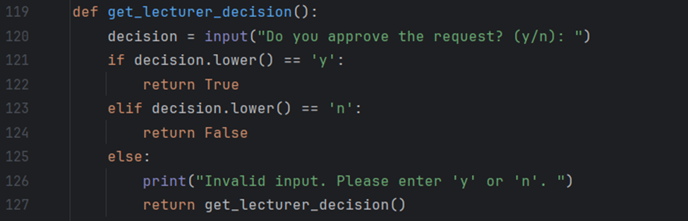

*Figure 3.1. 1: Array of if/else statements under the function get_lecturer_decision ()*

ii) For loop

A for loop is utilised for iterating through sequences like lists, strings, and tuples. In this program is mainly also depends on repeating methods for its basic functions to operate correctly. The programme frequently uses loops when the specific range of the iteration is known. For example, *‘update_student(students)’* function, a loop iterates through the ‘students’ list using the *‘for i’, student in enumerate(students)’* syntax. The ‘enumerate ()’ function retrieves the index ‘i’ and the student data as a list ‘student’ for every loop.

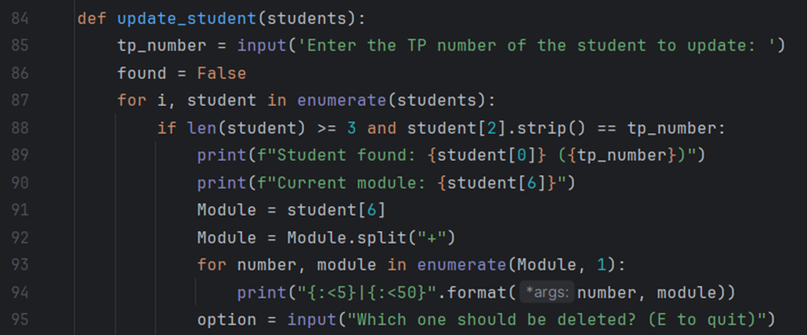

*Figure 3.1.2: For loop iterating through the 'students' list*

iii) While loop

Most of the codebase also comprised of while loops. The programme mostly consists of menu interfaces designed to keep the user within the menu screen until a relevant input is if matches the conditions set within the loop. The simplest example is the *‘main ()’* function, which serves as the primary page for the lecturer part of the programme. The *“while True:”* statement is utilized because it has the property of continuously keeping the user in a loop until a termination condition is met.

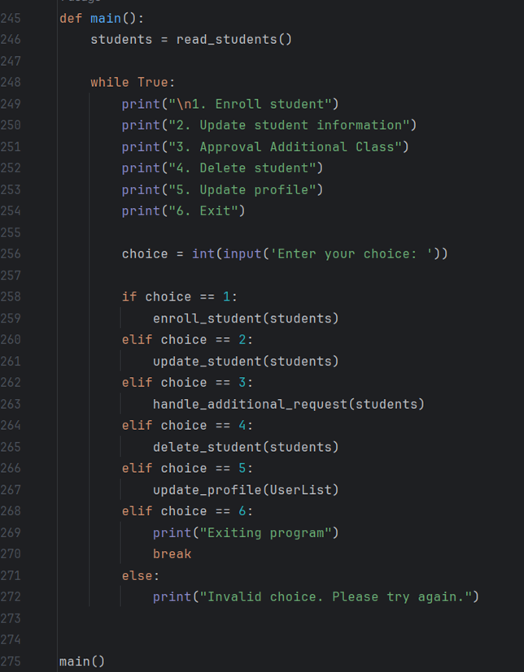

*Figure 3.1.3: While loop used in main function*

Another while loop is executed based on the positional arguments of functions within the *‘AssignModule()’* function. The while loop continuously prompts the user to input a module number and iterates as long as the user inputs valid numbers. The loop terminates if the user inputs a non-numeric character, and the function then returns the chosen module. The while loop has a layered while loop that asks the user to select the level of the chosen module. The loop iterated as long as the user inputs valid numbers and terminates if the user inputs a non-digit character or invalid option. These while loops enable the user to choose a module and its level from a list of available possibilities.

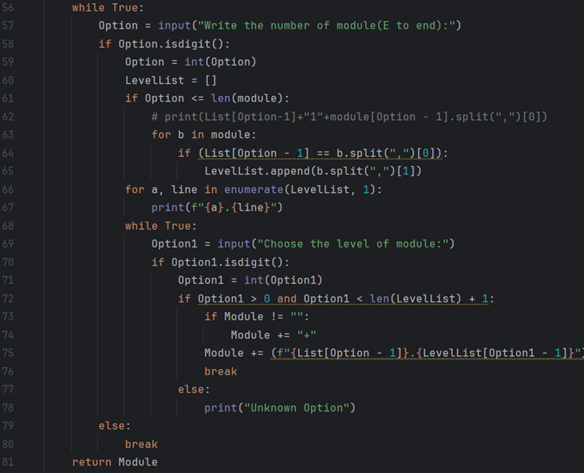

*Figure 3.1.4: While loop with multiple condition*

3.2 List

A list is also has been implemented in the lecturer part of the programme. Lists are used for their convenient referencing and manipulation through indexing, simplifying the execution of operations like functions that alter stored user data. Implementing this task becomes straightforward when a list may contain another list objects. For instance, the *‘students* ‘data consists of student information stored in the *‘read_students ()’* and *‘write_students ()’* operations. The system has a database of student information. Each entry includes the student’s name, password, TP number, email, contact number, address, module and enrolment details.

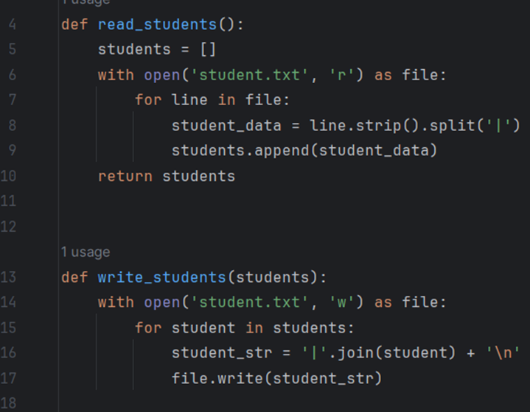

*Figure 3.2.1: A list object being contained within another list*

3.3 Functions

Following the modular programming method, specific code responsible for specified functionality is encapsulated within a function specification. This facilitates the targeted execution of code, unlike Python’s typical sequential code execution.

i)User-define function

User-defined functions are functions created by programmers to meet their own needs. An example in the lecturer part of the programme is *‘handle_additional_request(students)’,* a function that reads the contents of the *‘RequestAdditionalCoachingClass.txt’* file and enables the user to approve or reject requests for additional coaching courses. When a request is authorised, the related module is included in the student’s module list.

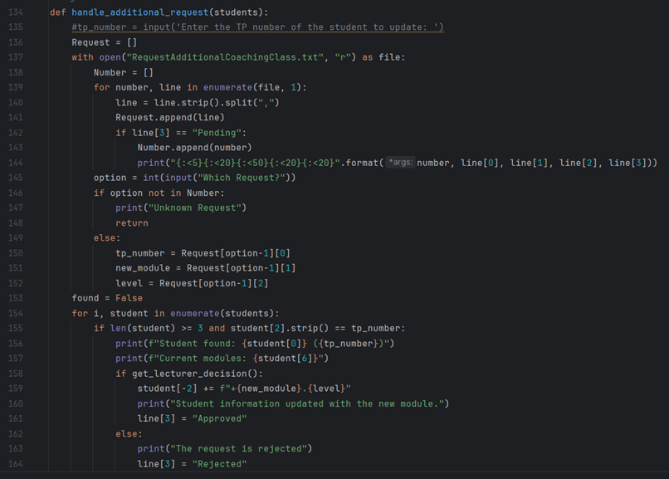

*Figure 3.3.1: user-define function (handle_additional_request(students))*

User-defined functions can be utilised in a sequence within certain procedural aspects of the programme, namely in the *'update_profile ()'* function where *'UserList [3] = Gmail', 'UserList [4] = ContactNumber', and 'UserList [5] = Address'* are assigned. The indexing operator '[]' is utilised to access and alter elements within the 'UserList' list.

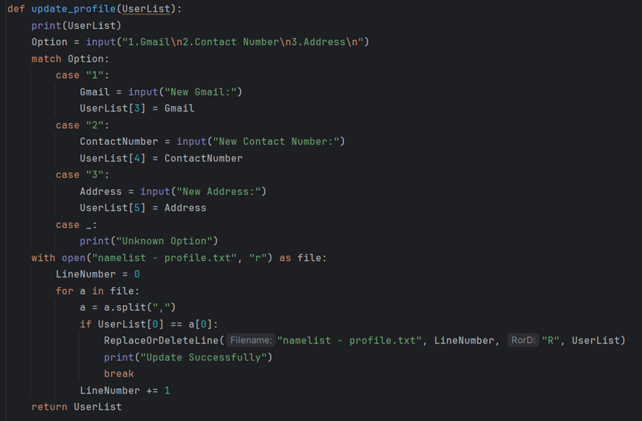

*Figure 3.3.2: Chained Functions*

ii) Built-in function

Built-in functions are predefined functions in programming languages included in libraries and can be called directly using specific keywords. One of the often-utilised built-in functions in the lecturer part of the programme is ‘input ().’ This function is utilised to receive input from the user. It receives user input at various points in the code, such as during student enrollment, deletion, or updating student information.

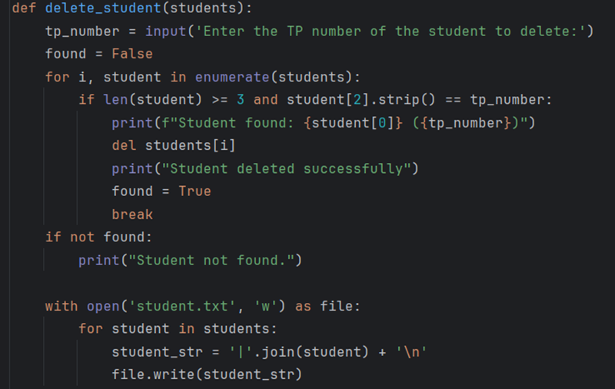

*Figure 3.3.3: Implementation of built-in function,’ input ()’*

3.4 File I/O

The lecturer part of this programme requires specific non-volatile information for optimum functionality. Python’s file handles may perform various operations like reading, writing, appending or overwriting files. File handles can be opened in read-only mode to safely access data without the possibility of overwriting it.



*Figure 3.4.1: Read text and Overwrite text in text file*

3.5 Variables

Python variables serve as containers for holding data values. A variable is a symbolic name that represents a value stored in the computer’s memory and is used to perform operations in the coding process. A variable refers to the location in memory where the data is kept. A variable can be assigned a value of one data type and later given a value of a different one. For instance, this programme includes a module that is a list of strings containing the data of all modules. The list comprises strings that consist of the name and code of a module, with some strings also carrying the term “(Additional)” if the module is an additional one.

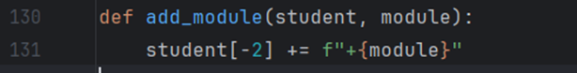

*Figure 3.5.1: Variable declaration with module*

## Student 4, Student (Sehba Hanief, TP078886)

1.Print():

The print() function is a built-in Python function that shows data on the standard output device, usually a console or terminal. The print() function accepts one or more arguments and, by default, separates them from spaces before printing them to the standard output.

Explanation:This code snippet reads the contents of a file and prints it to the console using the 'print()' method to show the requests that are currently in use.

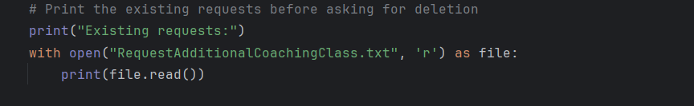

Figure 4. 1

2.Input():

The input() function is used to accept keyboard input from the user when a program is running in Python. The software will wait for the user to type something and hit Enter when input() is called. The text entered is then given back as a string.

Explanation:In this code snippet 'input()' function is used to ask the user for TP number, Modules and Level to delete a request.

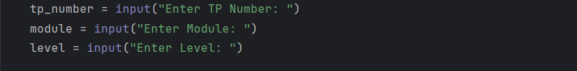

Figure 4. 2

3. Selection(if-elif-else):

Python controls flow statements like if, elif, and else are used to make decisions based on the assessment of one or more conditions.

Explanation:In the given code snippet, an if-elif-else structure is used at the beginning of the code to make judgments based on the value of the chosen variable.

* The view_schedule() method is called if choice equals "1". This suggests that the user is interested in seeing their schedule.
* Chooser calls the send_request() method if choice equals "2". This implies that the user wishes to submit an enrollment request for a different class.
* The delete_request() method is called if choice equals "3". This indicates that the user wants to remove a request that was already sent.
* The create_invoice() method is called if choice equals "4". This signifies the user's desire to view invoices.
* When choice equals "5", the make_payment() method is triggered. This suggests that the user is ready to pay.
* It invokes the Update Profile (UserList) method if choice equals "6". This suggests that the person wishes to make changes to their profile.
* It prints "Exiting..." and returns "q" if choice equals "0". This may indicate that the user wishes to stop using that software.
* It prints "Invalid choice" if any of the circumstances are not met (the user inputs an invalid choice). Kindly select a number from the list."

Because of this structure, the application can direct the user to various functionalities according to the input they choose.

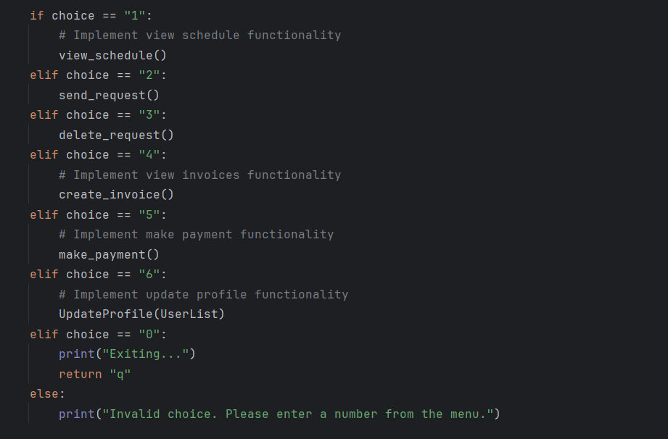

Figure 4. 3

4. Looping (for loop):

This code sample retrieves the contents of a file called "RequestAdditionalCoachingClass.txt" by looping through each line in the line's variable. Let us dissect the loop and examine how it works:

open(...) as the file:

This line starts write mode ('w') on the "RequestAdditionalCoachingClass.txt" file. The with statement guarantees that, following actions, the file is correctly closed.

for line within line:

A for loop that repeats through every line in the line's variable is started by this line.

lines are taken to hold the file's content, and the loop goes through each line one at a time.

if {tp_number}, {module}, {level} is not contained in a line:

If statement inside the loop establishes whether the string created by connecting the values for tp_number, module, and level is present in the current line.

The line is written to the new file if the condition is True, which indicates that the current line does not include the data that needs to be removed.

file.write(line):

If the condition in the if statement is True, this line writes the current line to the new file (in memory).

Printing the message "Request deleted successfully."

A message confirming the successful deletion of the request is printed once the loop has finished.

This loop's goal is to filter out and write all the lines that do not meet the predetermined requirements (tp_number, module, and level) to a new file. It involves deleting a request from the file based on the data supplied. When you wish to remove a particular record or entry from a data file, you frequently use this.

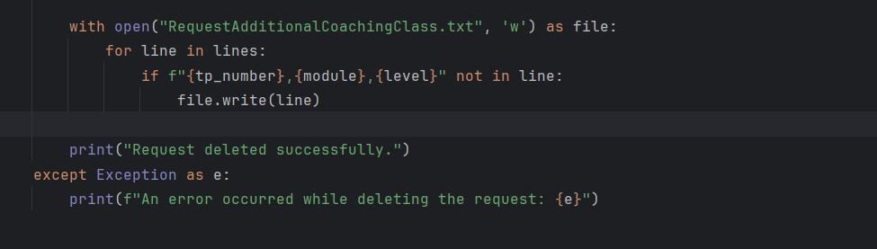

Figure 4. 4

5. Function:

def display_menu():

In Python, the def keyword is used to declare a function.

Parentheses (), which may contain parameters (in this case, none), come after the function name display_menu.

Block with Indentation:

The body of the function, or the set of instructions that will be carried out when the function is called, is included in the indented block that comes after the function definition.

print("Menu:"):

The word "Menu:" is printed on this line after the new line character (\n). The menu will become easier to understand as a result of the visual division this creates.

Statements to Print for Menu Items:

The print statements that follow print every menu item and its matching number.

A menu choice is displayed after each print statement, which is registered in the menu's order of aspect.

Function and Goal:

This function's goal is to make a menu visible on the console. It is a feature of the user interface that gives the user a list of options to select from.

examining the schedule, deleting a request, sending one to register in an additional class, examining invoices, paying, editing the profile, and ending the program are all options available from the menu.

Application:

This function can be called elsewhere in the program whenever there is a need to display the menu. For example, it might be called when the program starts or after the user completes a certain action.

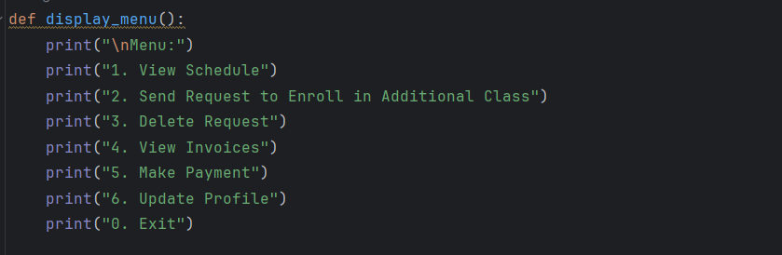

Figure 4. 5

6. File processing:

with open ("Coachingclassinformation.txt", "r") as file: This line opens a file called "Coachingclassinformation.txt" in read mode ("r") by using the with statement. Even if an exception arises during execution, the with statement guarantees that the file is correctly closed once its suite is completed. The variable file has the file assigned to it.

lines make a file.The function readlines() reads every line from the file and saves it in a list called lines. Every item in the list matches a line in the file.

A for loop is started with the line "for i, line in enumerate(lines)" to iterate over each line in the lines list. The content (line) and index (i) of each line are obtained using the enumerate () method.

line is data.strip(). split (","): The code splits each line into a list of values using commas as separators after removing leading and trailing whitespaces for each line using the strip () method. The variable data is allocated to the resulting list.

if data[4] == day and data[0] == level: This line checks a condition. It compares the value at index 4 of the data list with the value of the variable day and the value at index 0 of the data list with the value of the variable level. If both conditions are true, the code inside the if block is executed.

print(f"{data[0]}, {data[1]}, {data[2]}, {data[3]}, {data[4]}, {data[5]}, {data[6]}, {data[7]}"): If the conditions are met, this line prints specific elements from the data list using an f-string. It formats and displays information from the line that satisfies the conditions.

In summary, the code processes a file named "Coachingclassinformation.txt," reads its lines, and for each line, it splits the content into a list of values. It then checks specific conditions on the values in the list and prints selected elements if the conditions are met. This type of file processing is commonly used to extract and display information based on certain criteria from a structured text file.

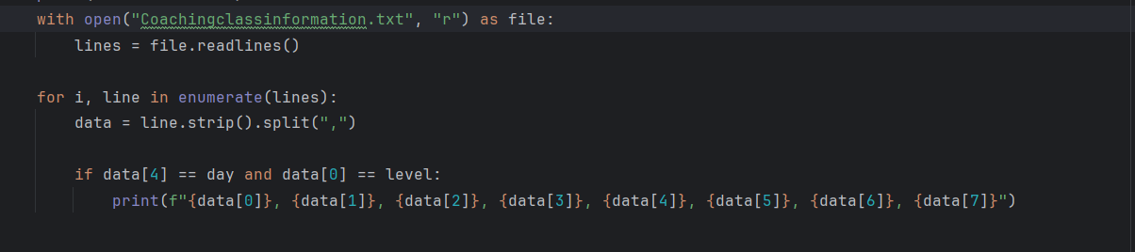

Figure 4. 6

# Additional features source code with explanation (if have).

## 

## Student 1, Administrator (Ng Ming Le, TP079013)

## 

## Student 2, Trainer (Manreen Kaur A/P Jagjit Singh, TP071290)

## 

## Student 3, Lecturer (Nurul Aiman Binti Raizal Azhar, TP079309)

## Student 4, Student (Sehba Hanief, TP078886)

# Screenshots of sample input/output (for the whole system).

System Main Page

This the main page where when user run it will ask for username and password

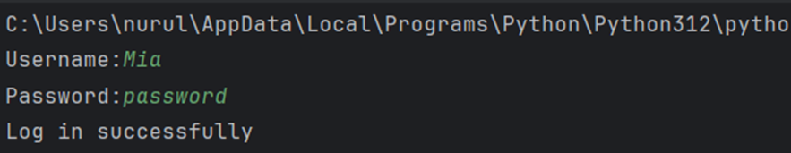

*Figure 1: Main page of the whole system*

Functionalities of Admin

1. Login to access system
   1. For admin to access the system it needs to login with their registered username and password

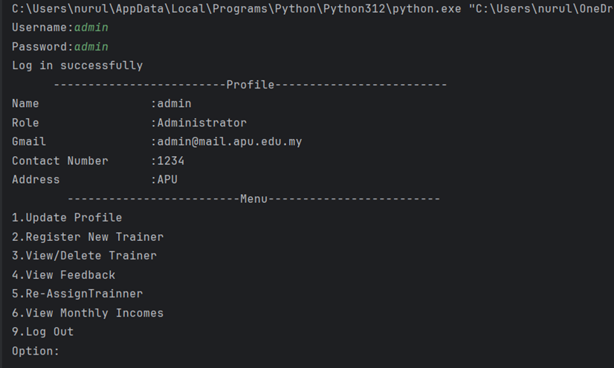

*Figure 2: Admin successfully log in and access the system*

1. Update Profile
   1. For Admin to update their own profile choose option ‘1’

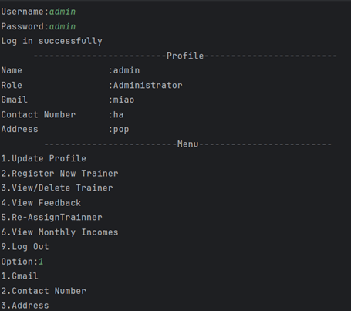

*Figure 3: Select option 1 to update profile*

* 1. Choose a number which to update email, contact number or address

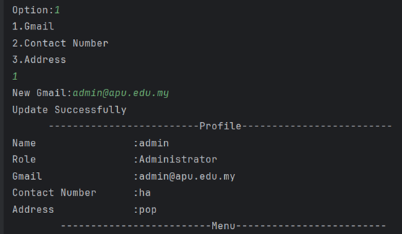

*Figure 4: Successfully update Gmail*

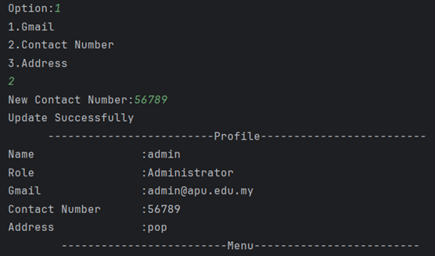

*Figure 5: Successfully update contact number*

1. Register New Trainer
   1. To register new trainer, enter option ‘2’

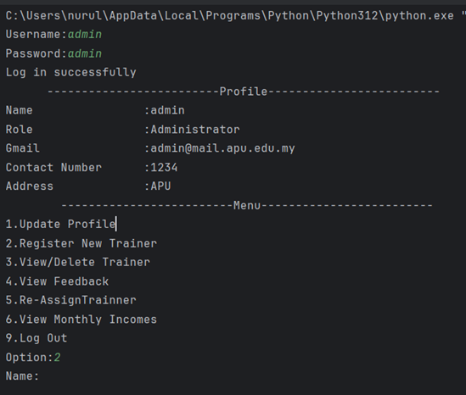

*Figure 6: Select option to register new trainer*

* 1. Enter information to register new trainer and choose which level and module to teach

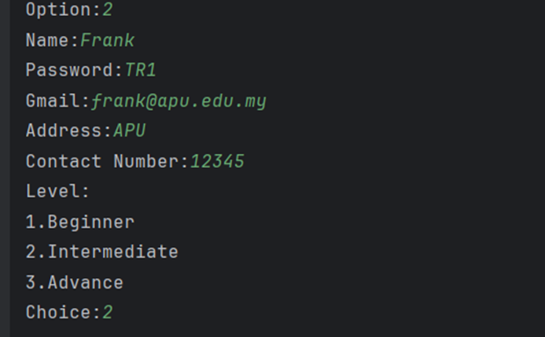

*Figure 7: Register trainer information*

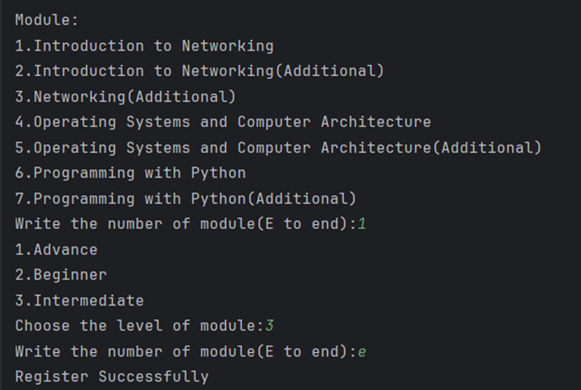

*Figure 8: Enters module to teach for trainers*

1. View/Delete Trainer
   1. To view and delete trainer enter option 3

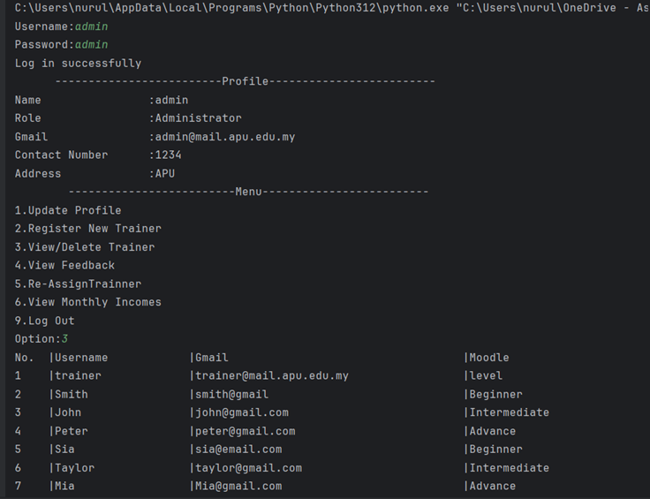

*Figure 9: View Registered Trainer*

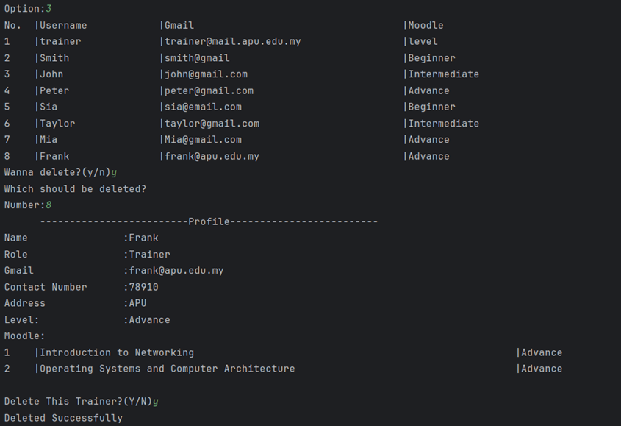

*Figure 10: Delete Trainer*

1. View Feedback
   1. To view feedback, enter option ‘4’

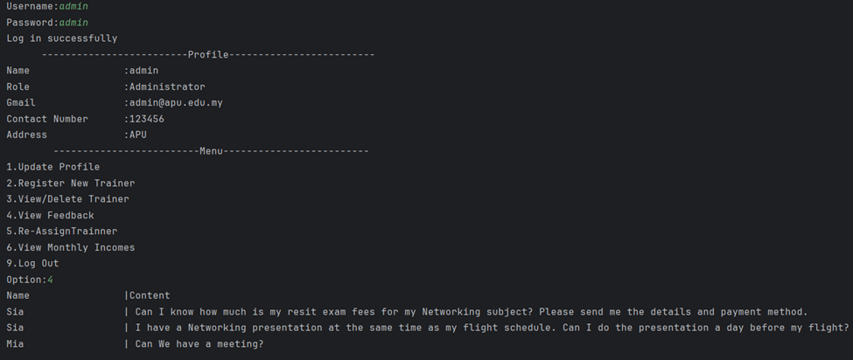

*Figure 11: Option 4 to view feedback*

1. Re-Assign Trainer
   1. Enter ‘5’ to Re-Assign Trainer level and module

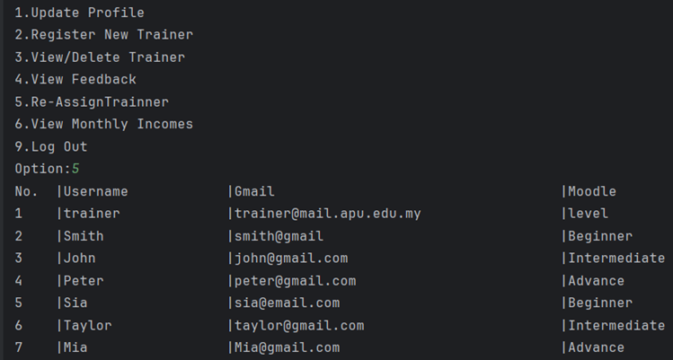

*Figure 12: Select option 5 to Re-Assign Trainer*

* 1. Enter respective number to select which trainer details needs to be modify

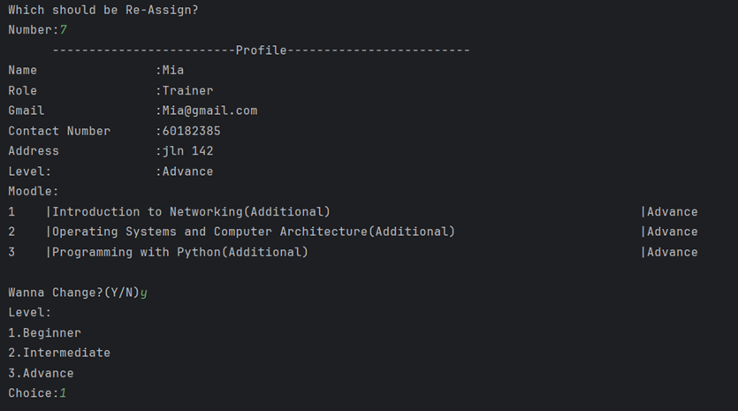

*Figure 13: Select trainer to re-assign*

* 1. Choose which level and module to change

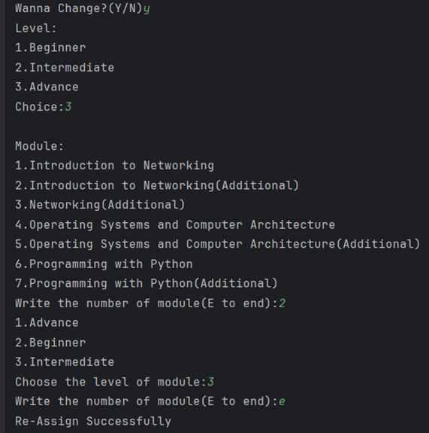

*Figure 14: Re-Assign Trainer*

1. View Monthly Incomes
   1. Enter option ‘6’ to view monthly incomes

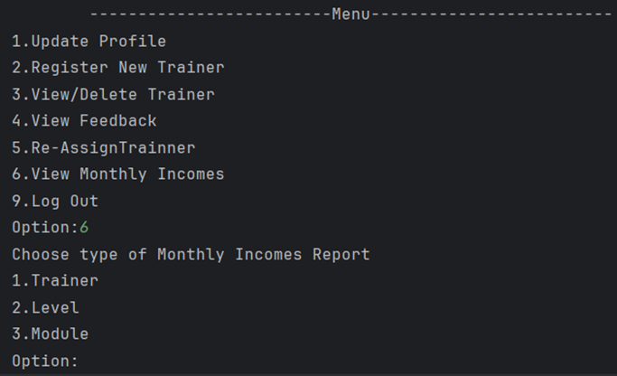

*Figure 15: Select option to view monthly incomes*

* 1. Enter respective number to view monthly incomes report

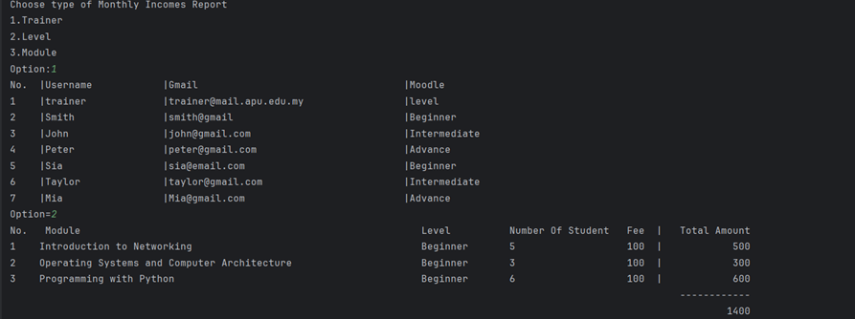

*Figure 16: Trainer Monthly Income Report*

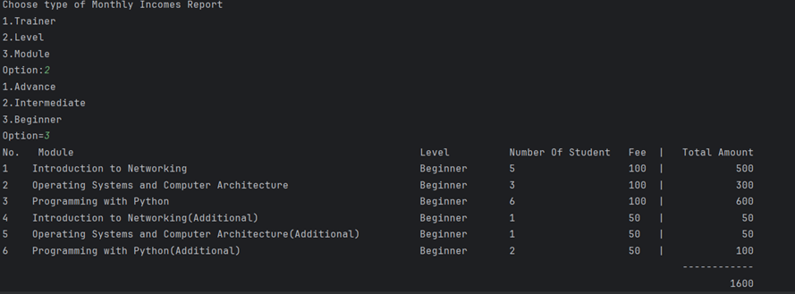

*Figure 17: Level Monthly Income Report*

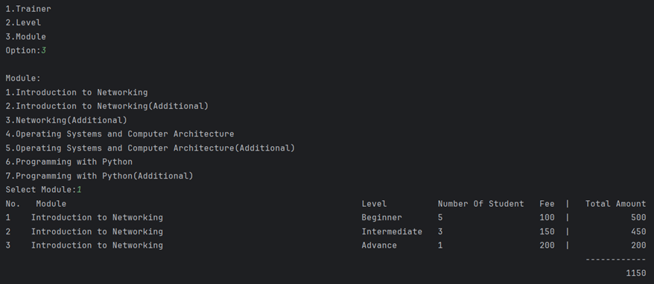

*Figure 18: Modules Monthly Income Report*

1. Exit
   1. To log out from the admin account enter option ‘9’

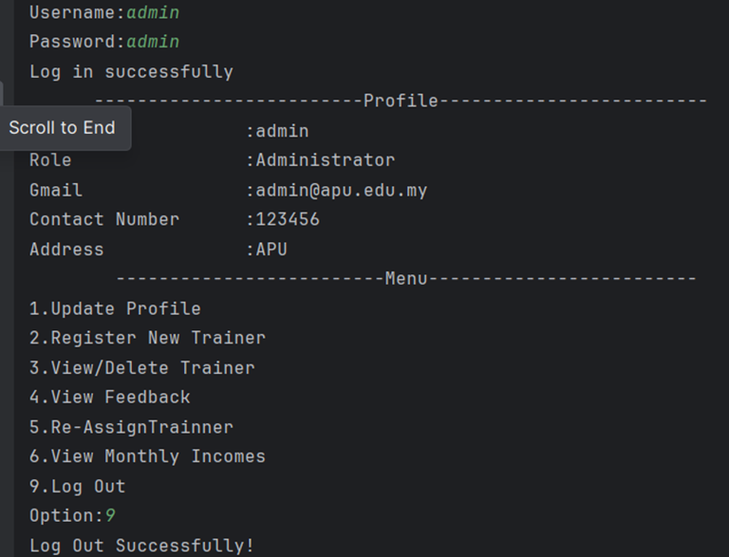

*Figure 19: Log out from Admin system*

Functionalities of Trainer

1. Login to access system
   1. Log in to trainer account to access the system

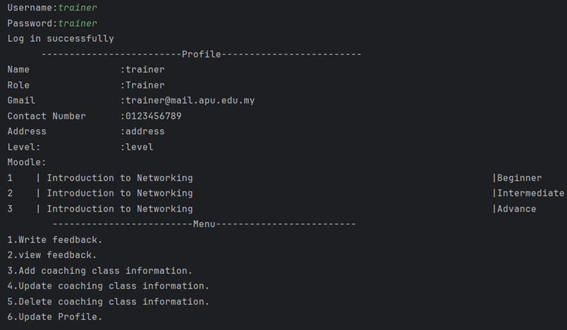

*Figure 20: Trainer successful login to access system*

1. Write Feedback
   1. To write feedback enter option ‘1’



*Figure 21: Trainer successfully submitted feedback*

1. View Feedback
   1. Enter ‘2’ to view feedback

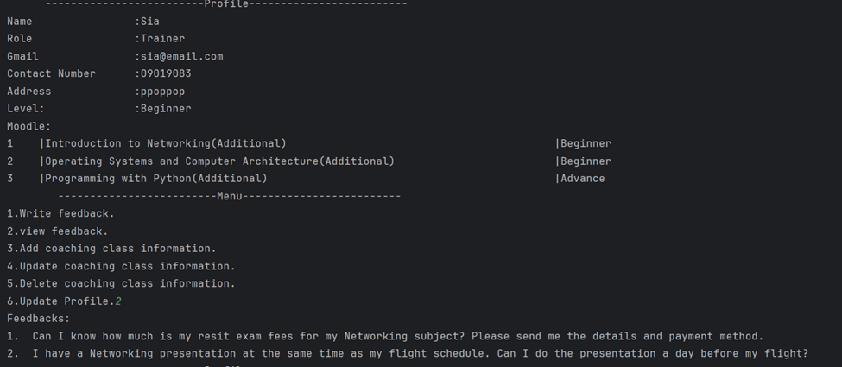*Figure 22: View submitted feedback Trainer*

1. Add coaching class information
   1. To add coaching class information, enter option ‘3’

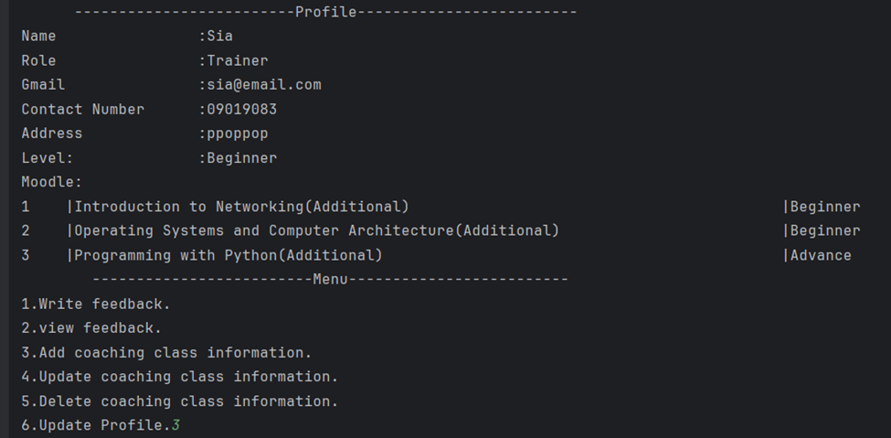*Figure 23: Selected option to add coaching class information*

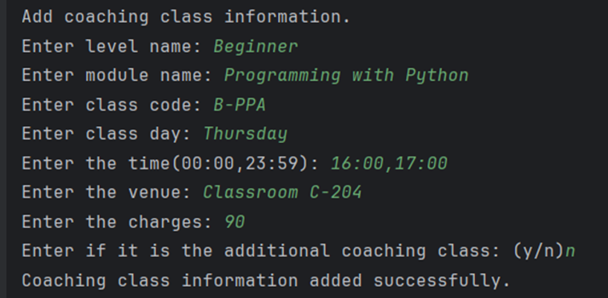

*Figure 24: Add coaching class information*

1. Update coaching class information
   1. To update coaching class, select option ‘4’

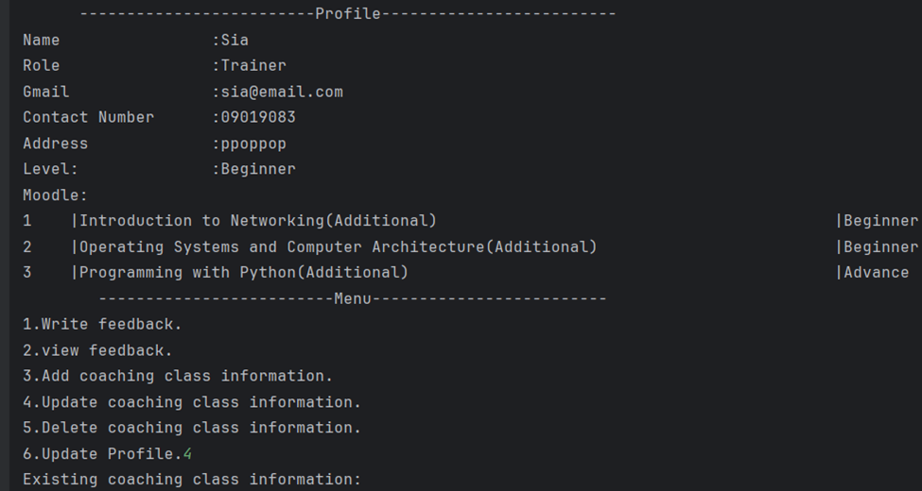*Figure 25: Updating coaching class information*

* 1. Enter respective number to update coaching class information

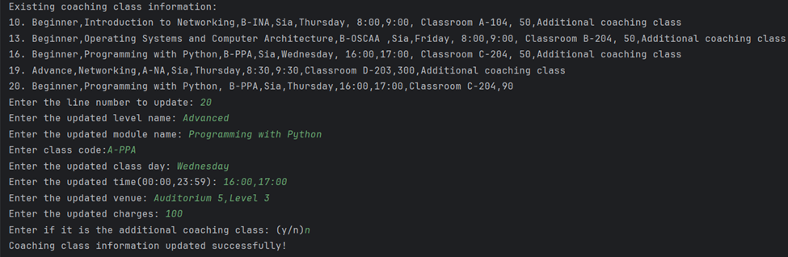

*Figure 26: Coaching class information updated successfully*

1. Delete coaching class information
   1. Select option ‘5’ to delete coaching class information

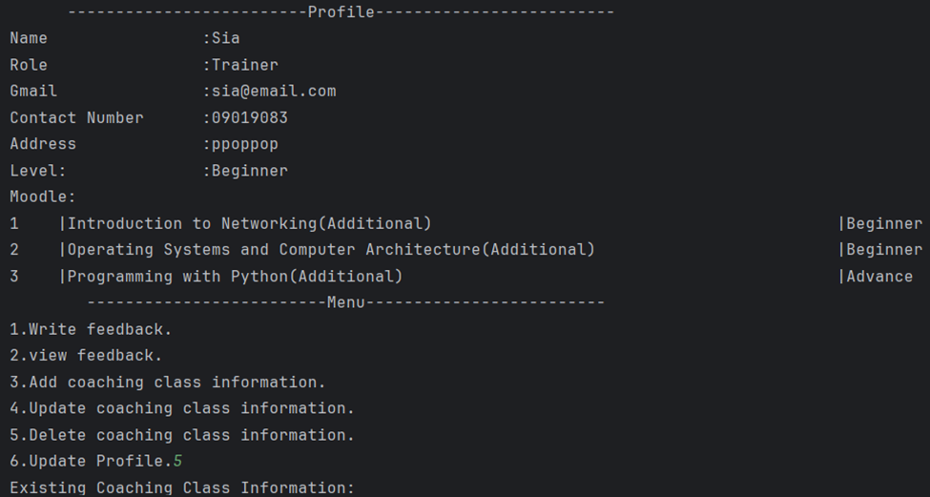*Figure 27: Delete coaching class information*

* 1. Enter a respective number to delete coaching class information

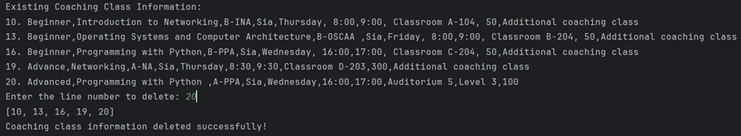*Figure 28: Line ‘20’ coach class information deleted*

1. Update Profile
   1. Select option ‘6’ to update profile

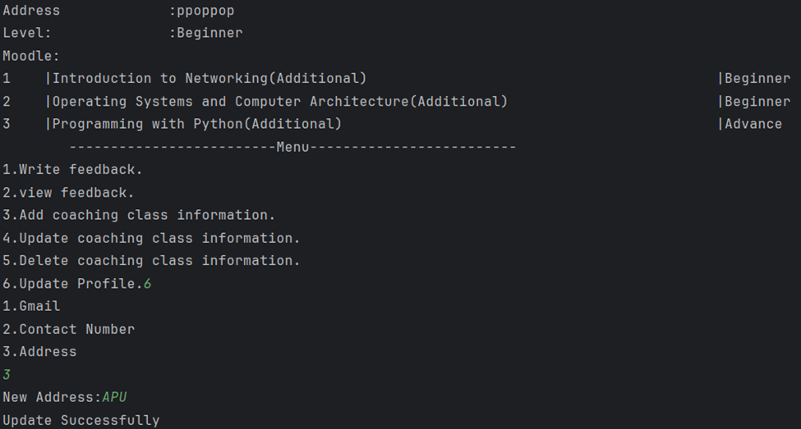*Figure 29: Update Profile*

Functionalities of Lecturer

1. Log in to access system
   1. For lecturer to access the system it needs to login with their registered username and password

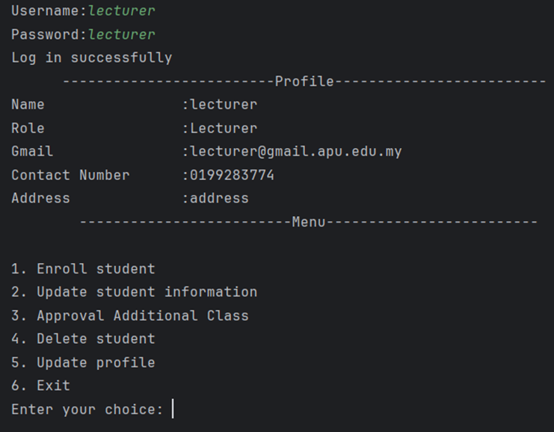

*Figure 30: Lecturer successfully log in and access system*

1. Enroll Student
   1. To enroll student, select option ‘1’

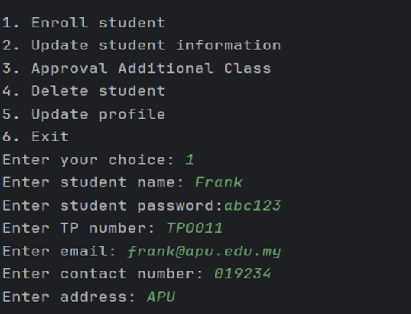

*Figure 31: Enroll a new student*

* 1. Enter respective number to register module for new student

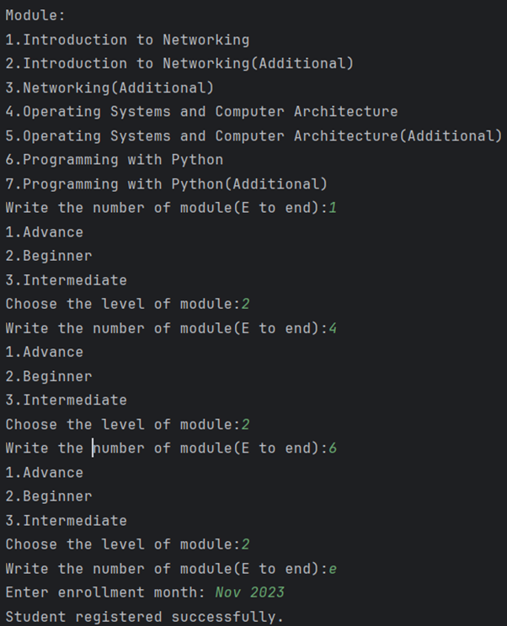

*Figure 32: Register module for new student*

1. Update student information
   1. Select option ‘2’ to update student information

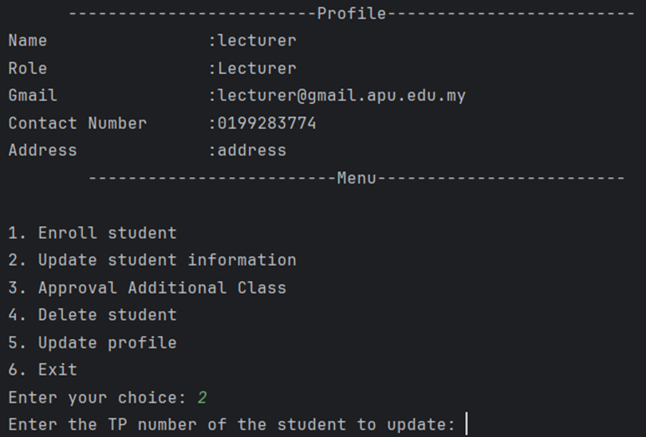

*Figure 33: Key in TP number student to update*

* 1. Student TP number entered to delete and update student module

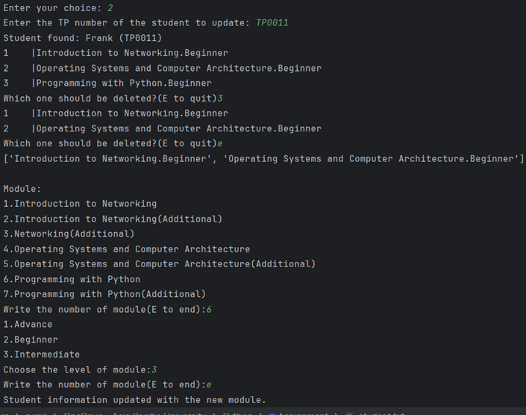

*Figure 34: Delete & Update Student Module*

1. Approval Additional Class
   1. Enter ‘3’ to Approve student additional class

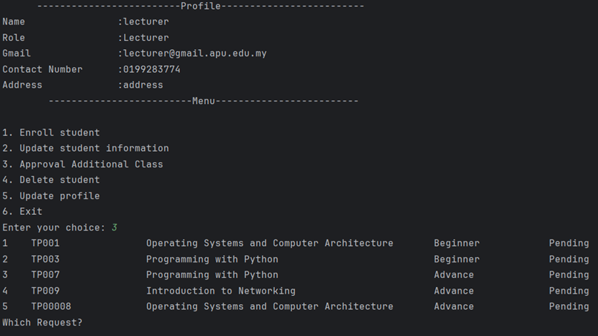

*Figure 35: Key in number to approve student*

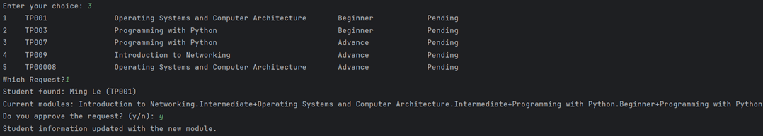

*Figure 36: Student requests approve by lecturer*

1. Delete Student
   1. To delete student, select option ‘4’

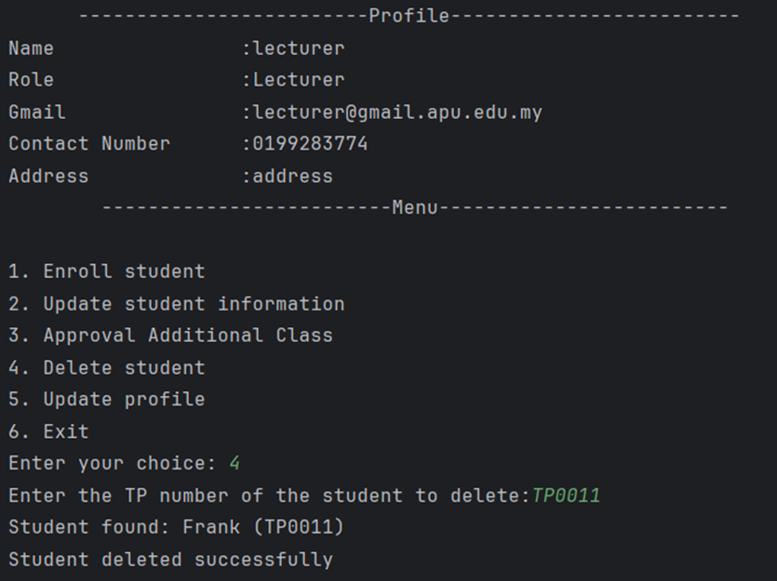

*Figure 37: Student has been deleted*

1. Update Profile
   1. Enter ‘5’ to update profile

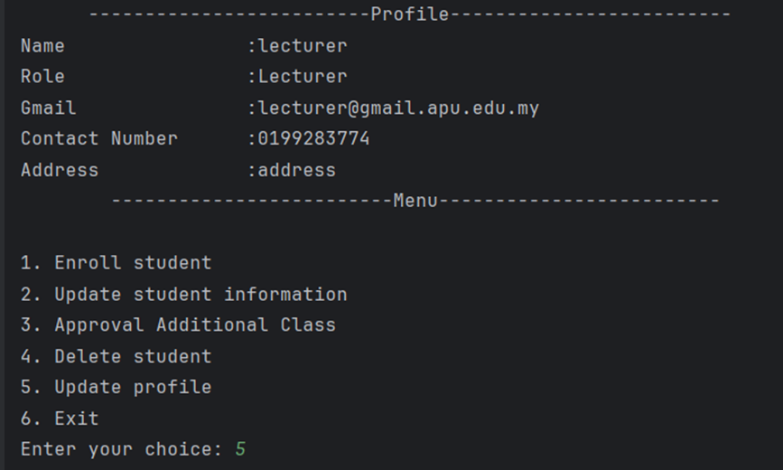

*Figure 38: Update Lecturer Profile*

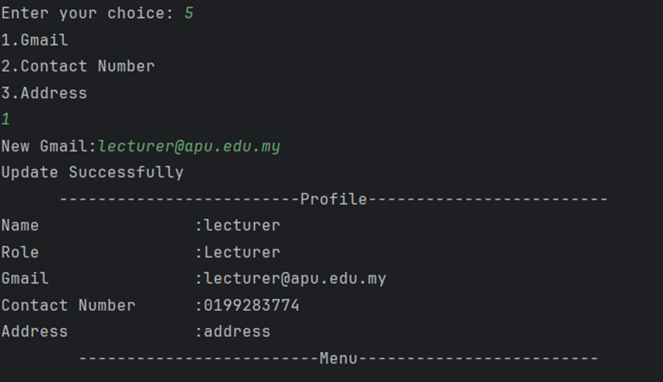

*Figure 39: Lecturer Email has updated*

1. Exit
   1. Enter ‘6’ to exit and log out

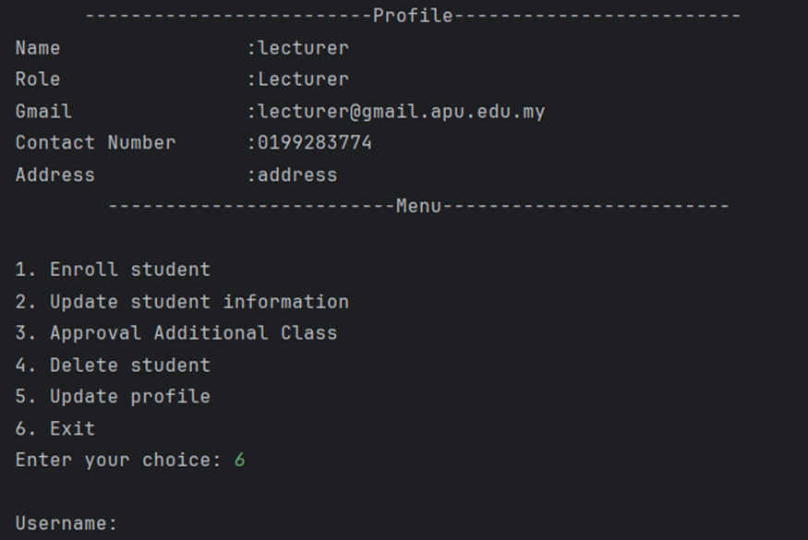

*Figure 40: Log out from lecturer account*

Functionalities of Student

1. Log in to access system
   1. Log in to student account to access the system

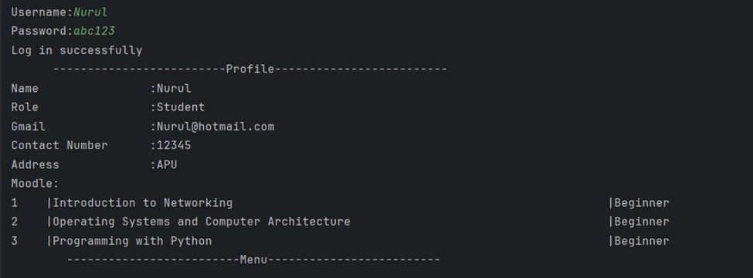

*Figure 41: Student log in successfully and access the system*

1. View Schedule
   1. Select option ‘1’ to view schedule

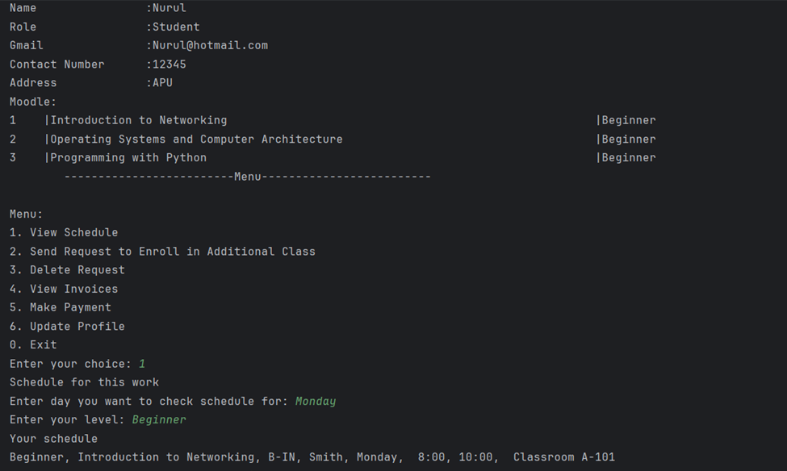

*Figure 42: View Student Schedule*

1. Send Request to Enroll in Additional Class
   1. Select option ‘2’ to send request to enroll in additional class

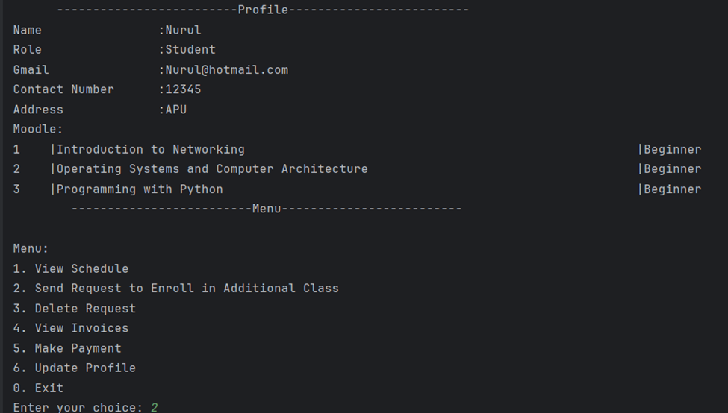 *Figure 43: Send Request to Enroll in Additional Class*

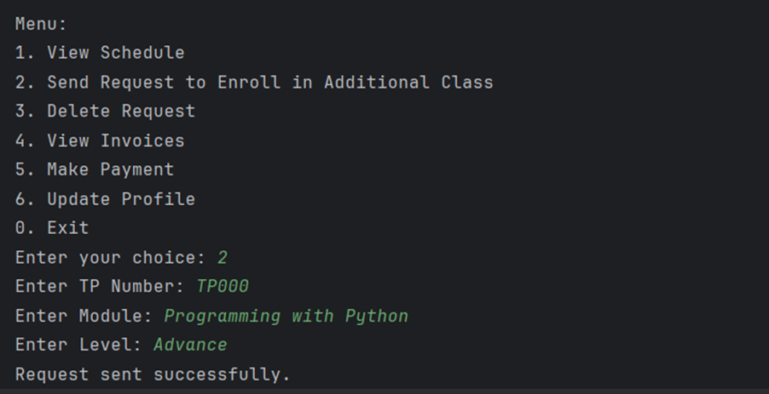

*Figure 44: Request sent successfully*

1. Delete Request
   1. Select option ‘3’ to delete request

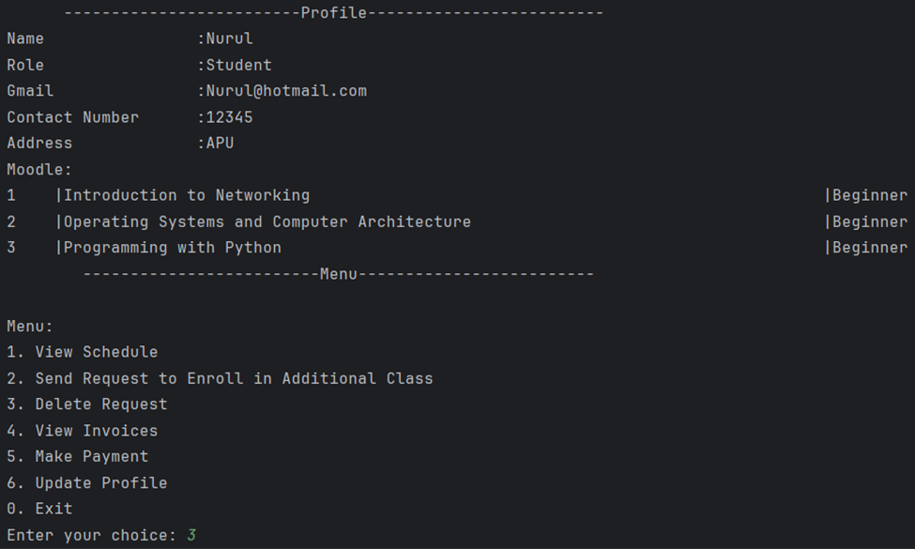*Figure 45: Delete request*

* 1. Enter student TP number which request to delete

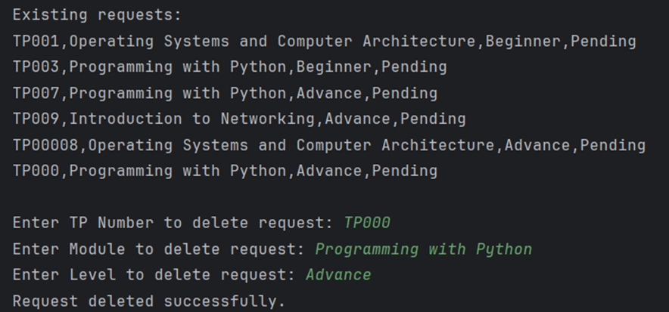

*Figure 46: Request delete successfully*

1. View Invoices
   1. Select option ‘4’ to view student invoices

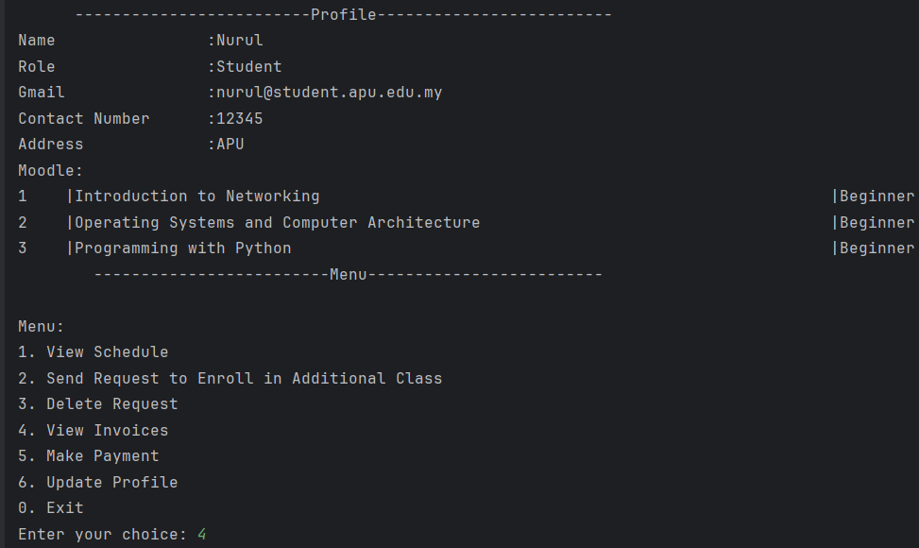

*Figure 47: View and Add Student Invoices*

* 1. Enter student TP number and module to add invoice

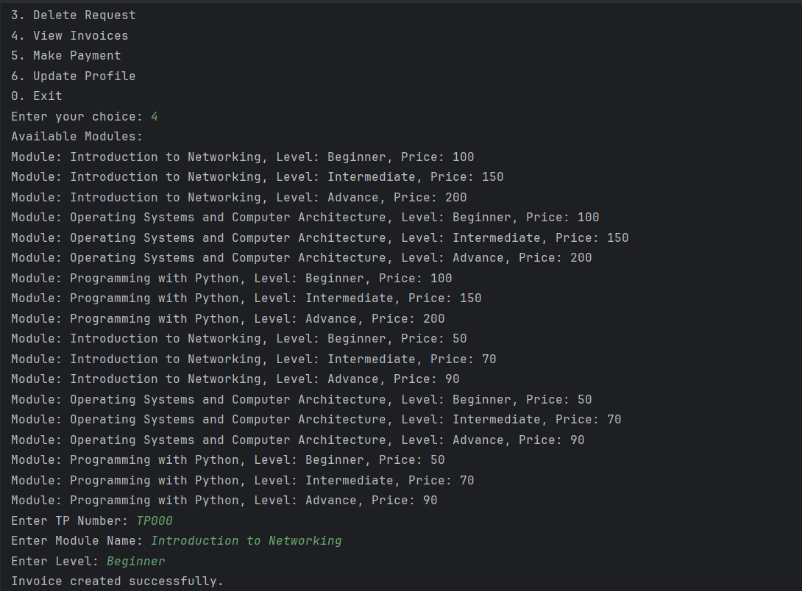

*Figure 48: Student Invoice created successfully*

1. Make Payment
   1. Select option ‘5’ to make payment

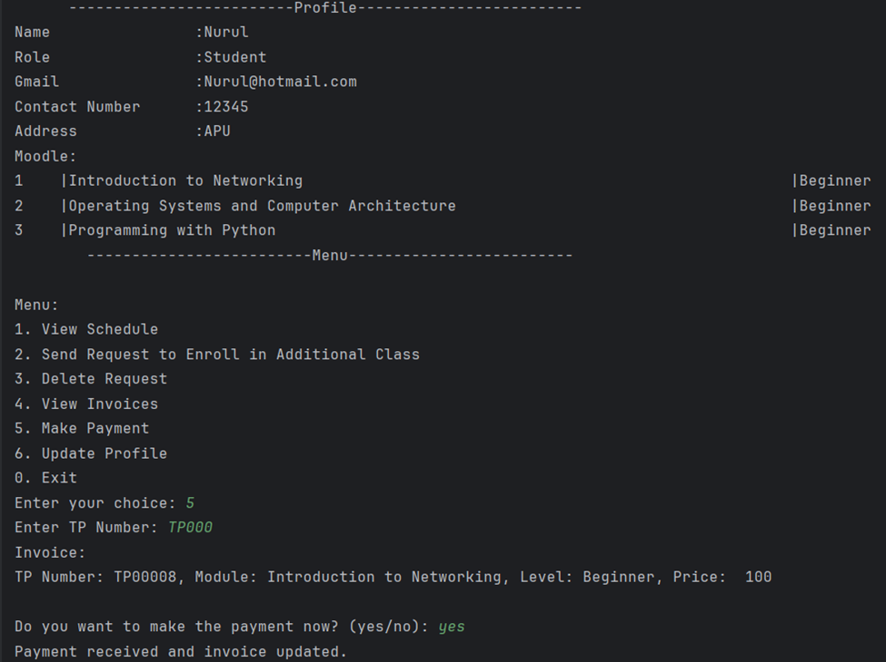

*Figure 49: Payment receiver and invoice updated*

1. Update profile
   1. Select option ‘6’ to update student profile

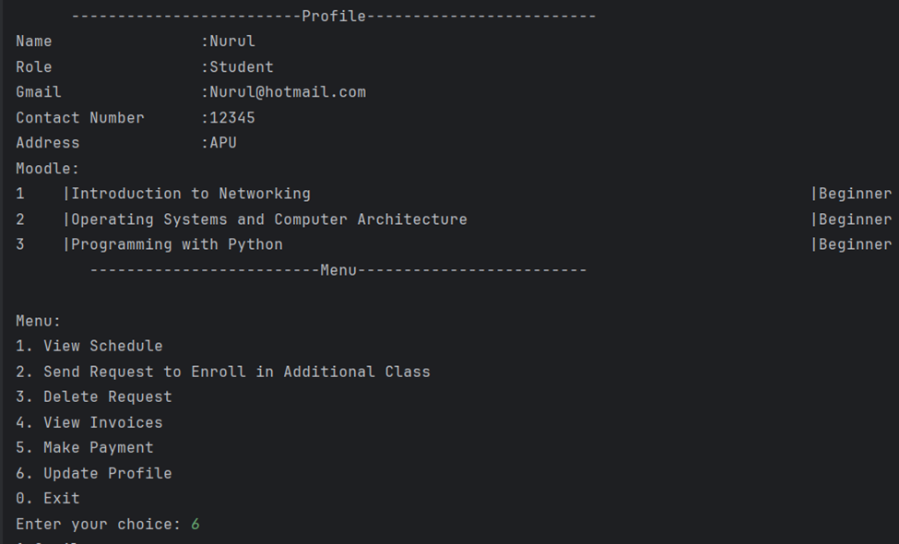*Figure 50: Select to update student profile*

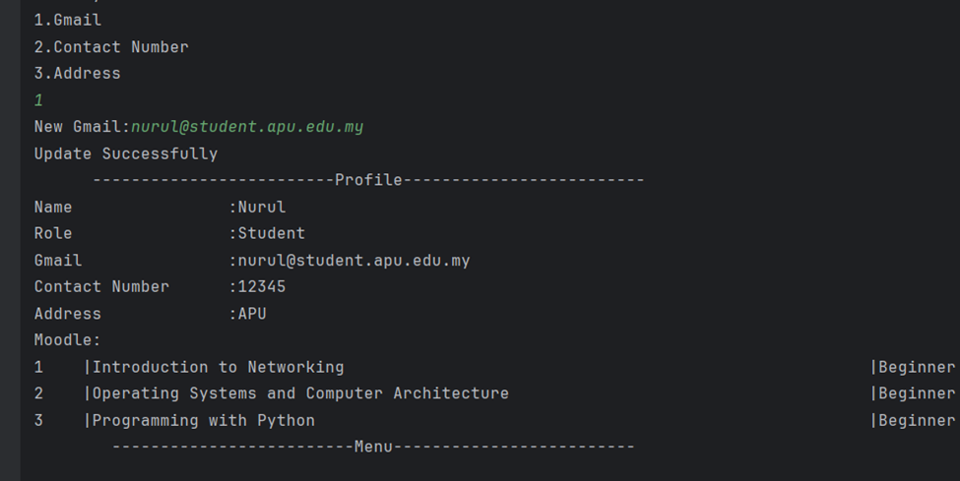

*Figure 51: Email student updated*

# Conclusion.

To conclude, based on the assessment of utilizing the Python application to establish the online management system for the APU Programming Café displays a notable milestone to ameliorate the educational exposure and guide framework for APU students to navigate their modules. The system successfully encapsulates the intricated requirements through meticulous scheming and execution producing a comprehensive suite of characteristics and functionalities constructed to the requirements of the roles.

To streamline the administrative processes is leveraged by technology to facilitate interaction, and optimize the allocation of resources, and adapt a conducive surrounding for academics. This system presents flawless user authentication procedure to navigate its roles, and menu choices. This seamless structure design is not only user-friendly but also systematic. In the future, the online management system of APU Programming Café is poise to transform conveyance coaching classes, enriches tutoring landscape and nurture students and educators. The maintenance and iterative refinement of the present-day system pledge to evolve in tandem based on the user’s dynamic needs and will establish a seamless system.

In essence, the online management system is not only developed advance but also commits students to succeed academically. With collaboration, the system will continue to improve in fostering a culture of learning and invention.

# References.

1. Chris, K. (2023, December 11). *How to call a function in Python - DeF Syntax example*. Retrieved from freeCodeCamp.org: <https://www.freecodecamp.org/news/how-to-call-a-function-in-python-def-syntax-example/>
2. GfG. (2023, December). *Reading and Writing to text files in Python*. Retrieved from <https://word-edit.officeapps.live.com/we/GeeksforGeeks.%20https:/www.geeksforgeeks.org/reading-writing-text-files-python/>
3. *How do i print the content of a .txt file in Python?* (n.d.). Retrieved from stack overflow: <https://stackoverflow.com/questions/18256363/how-do-i-print-the-content-of-a-txt-file-in-python>
4. *Python | Remove empty strings from list of strings*. (2023, April). Retrieved from Geeks for geeks: <https://www.geeksforgeeks.org/python-remove-empty-strings-from-list-of-strings/>
5. *Python Examples*. (n.d.). Retrieved from Programiz: <https://www.programiz.com/python-programming/examples>
6. *Python for Loop*. (n.d.). Retrieved from Programiz: <https://www.programiz.com/python-programming/for-loop#google_vignette>
7. *Python Tutorial*. (n.d.). Retrieved from <https://www.w3schools.com/python/default.asp>
8. *Python Variables*. (n.d.). Retrieved from Future learn: <https://www.futurelearn.com/info/courses/introduction-to-programming-with-python-fourth-rev-/0/steps/264867#:~:text=Python%20variables%20are%20simply%20containers,containers%20for%20storing%20data%20values>.
9. Simplilearn. (2023, January). *An Introduction to Enumerate in Python with Syntax and Examples*. Retrieved from simplilearn: <https://www.simplilearn.com/tutorials/python-tutorial/enumerate-in-python#:~:text=Enumerate()%20is%20a%20built,form%20of%20an%20enumerate%20object>.
10. Simplilearn. (2023, February). *What is A Dictionary In Python*. Retrieved from Simplilearn: <https://www.simplilearn.com/dictionary-in-python-article>
11. *Student management system in Python*. (2022, August). Retrieved from Geeks for Geeks: <https://www.geeksforgeeks.org/student-management-system-in-python/>

## Work Breakdown Structure

|  |  |  |
| --- | --- | --- |
| Number | Task | Name |
| 1. |  |  |
|  | Introduction. | Manreen Kaur A/P Jagjit Singh |
|  | Assumption. | Sehba Hanief |
| 2. | Design of the program. |  |
|  | Student 1, Pseudocode, Administrator | Ng Ming Le |
|  | Student 2, Pseudocode, Trainer | Manreen Kaur A/P Jagjit Singh |
|  | Student 3, Pseudocode, Lecturer | Nurul Aiman Binti Raizal Azhar |
|  | Student 4, Pseudocode, Student | Sehba Hanief |
| 3. | Explanation of Programming Concepts |  |
|  | Student 1, Administrator | Ng Ming Le |
|  | Student 2, Trainer | Manreen Kaur A/P Jagjit Singh |
|  | Student 3, Lecturer | Nurul Aiman Binti Raizal Azhar |
|  | Student 4, Student | Sehba Hanief |
| 4. | Additional features source code with explanation (if have). |  |
|  | Student 1, Administrator | Ng Ming Le |
|  | Student 2, Trainer | Manreen Kaur A/P Jagjit Singh |
|  | Student 3, Lecturer | Nurul Aiman Binti Raizal Azhar |
|  | Student 4, Student | Sehba Hanief |
| 5. | Screenshots of sample input/output (for the whole system). | Nurul Aiman Binti Raizal Azhar |
| 6. | Conclusion | Ng Ming Le  Manreen Kaur A/P Jagjit Singh |
| 7. | References | Sehba Hanief |
| 8. | Work Breakdown Structure | Ng Ming Le |